
М.Ғабдуллин атындағы №3
көптілде оқытатын кәсіби
мектеп – гимназиясы

1-сыныптың ағылшын тілі сабақтарында тіл дамытудың заманауи жолдары
Оқу-әдістемелік құралы

А.С.Уразбекова
Ағылшын тілінің мұғалімі

Көкшетау,2015ж
МАЗМҰНЫ
Түсініктеме 5
Оқу тақырыптық жоспар 13
Сабақ жоспарлары 17-49
Бастауыш сынып мұғалімдеріне жалпы
кеңестер мен ұсыныстар 50
Қолданылған әдебиеттер тізімі 55
Қосымшалар (CLIL сабақтар және ойындар)

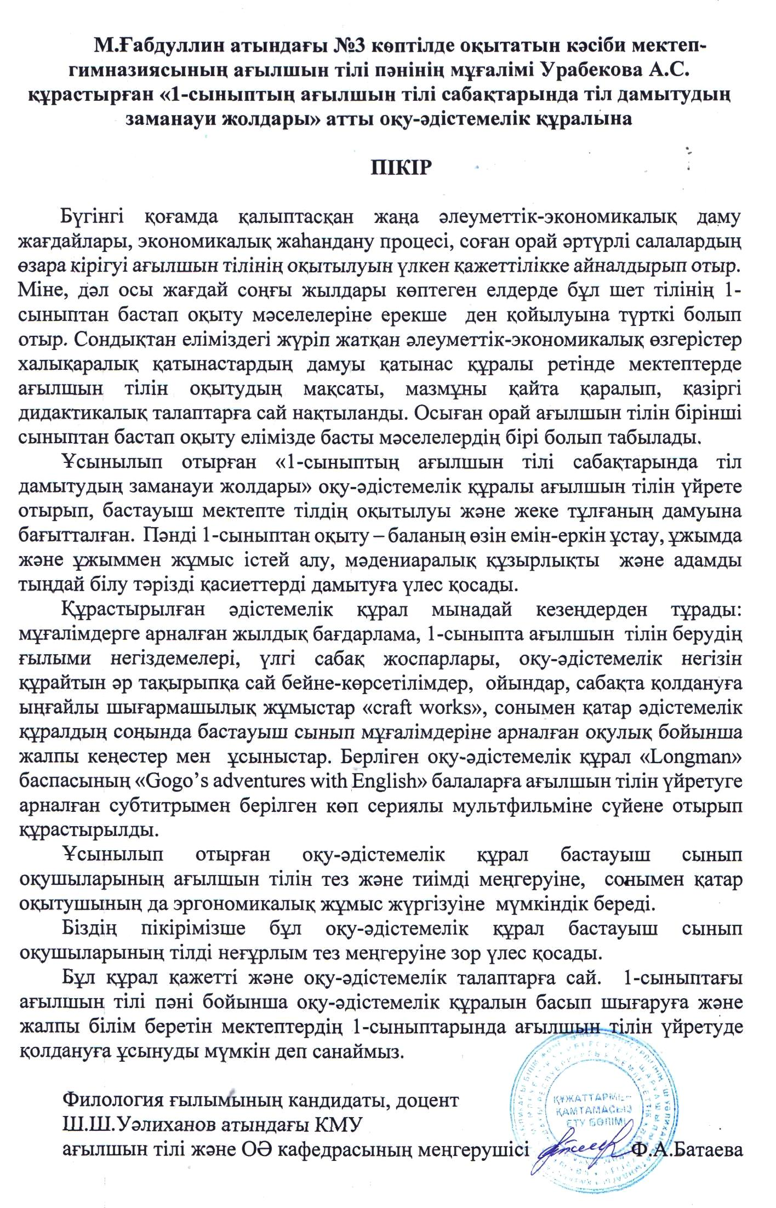
Уразбекова А.С.
Түсініктеме

Қазақстан Республикасының жалпы білім беретін мектептерінде оқыту үдерісі Қазақстан Республикасы Үкіметінің 2012 жылғы 23 тамыздағы №1080 қаулысымен бекітілген орта білім берудің (бастауыш, негізгі орта, жалпы орта білім беру) стандарттарына сәйкес 1-4 сыныптарға арналған «Ағылшын тілі» пәні бойынша оқу бағдарламасының негізінде 1-сыныпта ағылшын тілі сабақтарын ұйымдастыру жөнінде ұсыныстарды қамтиды.
1-cыныпқа арналған оқу-әдістемелік құралы кешендік және ауызша алға озу принциптері бойынша 1-сыныпта ағылшын тілін үйретуде аудио және бейне құралдарын негізге ала отырып, оқушылардың тілін дамытуды мақсат етеді.
«1-сыныптың ағылшын тілі сабақтарында тіл дамытудың заманауи жолдары» оқу –әдістемелік құралының мақсатқа орай міндеттері:
- ағылшын тілінде сөйлеу ортасын құру;
- ағылшын дыбыстарының арти куляциясы мен дұрыс айтылу дағыдысын қалыптастыру;
- басқа тілді есту арқылы дұрыс қабылдау дағдыларын қалыптастыру
- болымды, болымсыз, сұраулы сөйлемдерге дұрыс екпін қою дағдыларын қолыптастыру;
- белгілі бір тақырып шеңберінде монологтік және диалогтік сөйлеу дағдыларын қалыптастыра отырып, қажетті сөздік қорын, тілдесу тәсілдерін қамтамасыз ету;
Бастауыш сынып оқушыларына ағылшын тілін үйрету ерекшеліктері
Сабақ мазмұны:
1. Әр сабақ таза ағылшын тілінде өтуі міндетті, өйткені оқушыларға үйреніп жатқан тілдін ортасын жасау қажет. Неғұрлым тілді көбірек естісе, олар соғұрлым тезірек үйренеді.
2. Балалардың сабаққа деген қызығушылығын арттыру мақсатында, ойын ойнату, ән айтқызу, тақпақтар қолдану қажет.
4. Егер оқушылар сөйлегенде қате жіберіп жатса, сол сәтте тоқтатып, түзетуге болмайды. Ең бастысы, оқушы сабақта мұғалімнен қорықпай, өзін еркін сезініп, сабаққа жақсы көңілмен қатысатындай жағдай жасау керек.
5. Олар түсіне алатындай әңгімелер айту, дауыс ырғағын келтіре отырып сол әңгіме мәтіндерге байланысты суреттер, маскалар, қуыршақтар, ойыншықтар пайдалану керек.
6. Оқушылардың белгілі тақырыпты жақсы түсінуі үшін, сабақтарда берілетін мысалдарды олардың өмірімен әрдайым байланысқан түрде беріп отыру керек.
7. Әр уақытта оқушылардан ақыл-кеңес сұрай отырып, бірігіп жұмыс істеу керек.
8. Сыныпта отырған оқушылардың темпера-менттерінің әртүрлі болуына байланысты олардың сабаққа қатысуы да әртүрлі. Кейбіреулері өте белсенді, ал басқалары аса белсенділік таныта қоймайды. Осы жікті бірдейлеу мақсатында көбінесе топтық жұмыстар жүргізген дұрыс. Осы жұмыс түрінде белсенділігі төмен оқушылар, белсенді оқушылар қатарына тартылады. (мұғалімнен сұрауға ұялған сұрақтарын, топта сұрап, жауап алады).
Мұғалім қалай көмек береді:
- Әр сабақта балалардың сабаққа деген қызығу-шылығын арттыру мақсатында ойындар, әндер, аудио-бейне көрсетілімдер, күлкілі жағдаяттар, қысқа санамақтар қолданып отыру;
- Олардың қатесіне көп көңіл бөлмеу, ең бастысы, олар сабаққа жақсы көңілмен қатысатындай жағдай жасау, олар сабақта мұғалімнен қорықпай, өзін еркін сезінетіндей болу;
- Сабақта суреттер, өлеңдер, жұмбақтар қолдану;
- Олар түсінетіндей әңгімелер айту және дауыс ырғағын келтіре отырып, сол әңгімелерге байланысты суреттер маскалар қолдану;
- Егер олар өз тілдерінде айтып жатса, айтылғанды оған ағылшынша аударып, қайталатып отыру.
Тыңдауға үйрету
Бастауыш сынып оқушылары естігенді тез қабылдайды, сондықтан сабақ барысында тек ағылшын тілін қолдану, оқушылардың ағылшын тілін көп естуі маңызды. Әрине оқушылар ана тілінде айтқаннын бәрін жақсы түсінеді, уақыт үнемделеді, дегенмен мұғалім мақсаты – бұл ағылшын тілін үйрету. Әр сабақта мұғалім ағылшын тілінде сөйлесе, соны талап етсек, онда мақсатымызға жетеміз.
Оқушылар көп тыңдау жаттығуларын жасағанда:
- тыңдау арқылы түсінуді үйренеді
- көптеген сөздер мен фразаларды игереді
- сөз қоры көбейеді
- тыңдағанды сауатты түрде айтып үйренеді
- дыбыстар мен екпіндер дауыс ырғақтары дұрыс менгеріледі
Тыңдап түсінгенін іс-қимылмен көрсетуде:
- мұғалім оқушыларға не істейтіндерін таныстырады
- сөйлемде түсінікті, әдемі дауыс ырғақпен айту, дыбыстарды дұрыс айту
- әр-түрлі іс қимылдар арқылы түсіндіру
Ұсынылып отырған оқу-әдістемелік құрал бейне материал негізінде құрастырылған. Сондықтан балалар тыңдап қана қоймай, бейнелік еске сақтау арқылы қабыдап түсінеді.

Сөйлесуді үйрету
Сөйлесуді үйрену жаңа сөздерді сабаққа еңгізілгеннен басталады:
- Күнделікті сабақта айтылып жүрген фразаларды оқушылар түсінеді, айтады, жаңа лексиканы игерген сайын олардың сөздік қоры көбейіп отырады. Оқушылар мұғалімді тыңдап, жаңа сөздермен фразаларды қайталағанда оларды бекіту мақсатында әр түрлі жұмыстар жүргізіледі, жаңа лексиканы еңгізгенде оқушылар тыңдайды, түсінеді, қайталайды, сол сөздерді сөйлемдерде қолданады;
- Жаңа сөздерді таныстыру кезінде дыбыстармен жұмысты ерекше жолға қою керек, кіргізілген жаңа сөздін әр дыбысы дұрыс айтылып қайталануы қажет.
- Сөйлесуге үйретуде жұптық, топтық жұмыстарды неғұрлым көп қолдану қажет. Диалог арқылы олар бір-бірімен амандасу, тансысу, жастарын, өмір сүріп жатқан жерлерін сұрайды, түр-түстер, уақытты айту, және заттарды суреттеуге сұрақ жауап арқылы үйренеді.
- Монологтік сөйлеу дағдысы тақырып бойынша әңгімелеу (4-5 сөйлем) арқылы қалыптастырылады.
Берілген оқу-әдістемелік құралдағы жаттығулар жүйесі тілдік материалды лексикалық, диалогтік, ойындар арқылы, сөйлемдерді қайталау жаттығулары және оқушылардың өмірімен байланысқан мысалдар келтіруі (үлгіге сәйкес өзара диалог құру) арқылы кезеңмен меңгеруге бағытталған. Аталған ойын түрлері оқушыларға жаңа сөздерді тізім бойынша құрып жаттап алуға емес, жақсы есте сақтауға көмектеседі. Қайталатқызу жаттығулары, өмірімен байланысқан мысалдар келтіру белгілі тақырыптар төңірегінде олардың коммуникативтік құзырын мақсатты қалыптастыруға ықпал етеді.
Берілген оқу-әдістемелік құралында МЖОБ-ға сәйкес 1-сыныптарда оқу мен жазу қарастырылмағандықтан, бұл дағдыларды игерту мақсат етілмейді, дегенмен оқу-әдістемелік құралдың негізін құрайтын субтитрлы бейне материал бейнелік есте сақтау әдісімен олардың оқу мен жазудың алғашқы сатысын игеруіне мүмкіндік береді.
Ағылшын тілін оқыту үрдісінде келесі пәндермен пәнаралық байланыс жүзеге асады:
- Математика
- Сурет
- Өзін-өзі тану;
- Музыка
Ұсынылған оқу курсында 1-сынып оқушылары мынаны меңгеруі тиіс:
- Берілген тақырып төңірегінде диалог және монолог құруда 3- 4 сөйлем құруға қажетті тілдік материалды меңгеру;
- ағылшын дыбыстарының дұрыс айтылуын меңгеру;
- болымды, болымсыз, сұраулы сөйлемдерге дұрыс екпін қоя білу;
- мұғалімнің, бейне материал кейіпкерлерінің айтқанын естіп, қабылдай алу, мазмұнын түсіну, үлгіге сүйене отырып, өз өмірлерімен байланысқан диалогтар, монологтар құру;
- сурет салу сарқылы түсінгендерін бейнелей алу.
Оқу-әдістемелік құралдың компоненттері:
1-сыныпқа арналған «1-сыныптың ағылшын тілі сабақтарында тіл дамытудың заманауи жолдары» атты оқу-әдістемелік құралы бейне материалдардан, мұғалімге арналған күнтізбелік-тақырыптық жоспар, сабақ жоспарлары, бастауыш сынып мұғалімдеріне арналған жалпы ұсыныстар мен кеңестерден, ойындар, балаларға арналған шығармашылық жұмыс парақтарының жинағынан тұрады.

Бейне материалдар
Берліген оқу-әдістемелік құрал «Longman» баспасының «Gogo’s adventures with English» балаларға ағылшын тілін үйретуге арналған субтитрымен берілген көп сериялы мультфильміне сүйене отырып құрастырылды. Мультфильмнің басты кейіпкерлері Gogo, Тonny, Jenny
Gogo – ағылшын еліне басқа ғаламшардан келген айдаһар.
Тonny мен Jenny – бұлар ағалы-қарындас кейіпкерлер. Олар Gogo –ның жердегі достары және оны ағылшын тіліне үйретеді.
Оқу-әдістемелік құралда берілген мультфильмнің 39 сериясының 28-і таңдалған тақырыптарға сай жүйеленді. Қолданылмаған бейне материалдарды әр мұғалім қалыптасқан оқу жағдайларына орай қалауынша қолдана алады.
Сабақ жоспарлары
ОӘҚ-дағы сабақ жоспарлары ағылшын тілі мұғалімдеріне үлгі ретінде ұсынылады, оқытушы оқыту барысында өз қалауынша түрлендіріп, өзгерте алады.
Сабақ жоспарлары күнтізбелік-тақырыпқа сай құрылды. Күнтізбелік –тақырыптық жоспары оқу бағдарламасына сай 33 сағат жылдық жүктемені құрайды. Әрбір тоқсан ауызша бақылау жұмыстары (Progress test) алынады.

Ойындар. Ойын –баланың өміріндегі ең маңызды іс-әрекет. Сондықтан да ойын – бұл кез келген пәнді балаға игертудің ең тиімді жолы, әсіресе, шет тілі пәндері үшін.
Бастауыш сыныптардың ағылшын тілі сабақтарында әртүрлі ойындар көмегімен тілдік материалды оңай және тез меңгертуге болады. Ең бастысы, ойынды сабақ барысында тақырыпқа байланысты шебер қолдана білу. Сондықтан да кез келген ойынды сабақта қолданарда біз төмендегідей жадынамаларда ескеру жөн деп білеміз:
1 Ойынды бастар алдында – оның ережесімен таныстыру, үлгі ретінде бір-екі оқушымен ойнап көрсету;
2 Ойын барысында еркіндік беру: баланың өзін көрсете алуына мүмкіндік туғызу;
3 Ойын барысында ағылшын тілін қолдану – білмейтін сөздерін кәртішкелер түрінде қабырғаларға жапсыруға немесе қолдарына таратып беруге болады;
4 Ойын ұзақ болмауы тиіс. Себебі ұзақ ойындар оқушыларды жалықтырып жіберуі мүмкін;
5 Ойынды сабақтың әртүрлі кезеңдерінде қолданған жөн.
6 Оқушылардың барлығының қатысуын қадағала
7 Ойында жиі қолданылатын фразалар:
Let’s play a game.
Do you want to play a game?
Make a circle.
Make to teams.
Sit on the floor.
Move your chairs over here.
Who wants to start?
Move your chairs over here.
Who would you like to be in the middle?
Who wants to be the team leader?
Find a partner.
Face your partner.
Play in/Get into groups of four
Take in turns.
Whose turn is it?
Ready, steady, go!

ОӘ-нің қосымшасында (Қосымша 1) ағылшын тілі сабақтарында қолдануға болатын ойындар қоры ұсынылады. Ойын атаулары ыңғайлылық хақында әліпби ретімен орналасқан.
Шығармашылық жұмыстар (CLILсабақтары )
Жалпы ағылшын тілін үйретуде шығармашылық жұмыстардың рөлі аса зор. Шығармашылық жұмыстар сабақ барысында әртүрлі жағдаяттарды рөлге салып ойнауға қолданылады, сол кезде оқушылар тілді, фразаларды жақсы есіне сақтайды немесе қолмен жасаған заттарды жасап отырып атын атау, бояп отырып түсін атау, сол туралы тақпақ немесе әндер айту олардың пәнге деген қызығушылығын әрдайым арттырып, тілді тез игертеді.
ОӘҚ-нің қосымшасында (Қосымша 2) ағылшын тілі сабақтарында қолдануға болатын әртүрлі ойындар жинағы, шығармашылық жұмыс үлгілері ұсынылады. Шығармашылық жұмыстар парақшалары «Macmillan» баспасының «Way ahead 1», «Cambridge» баспасының «Primary colours 1» оқулығынан алынды.

Оқу тақырыптық жоспары
1 тоқсан
Сабақ | Тақырып | Сағат саны | Тыңдалым | Сөйлесім
 | Hello! My name is.. | 2 | Video “Hello! What’s your name?” | Hello! What’s your name?My name is..How are you? Im fine! Good bye
 | Classroom objects. Is it a…  Yes. No. | 2 | Video “What is it?” | What is it/ It’s a…Is it a…  Yes. No.
 | What’s his/her name? | 1 | Video ”What’s her/his name? | What’s his/her name?  Her/his name is…
 | Numbers1-15 | 2 | Video “How old are you?” | Numbers1-15.How old are you? I’m 6. Thank you!
 | Progress test. | 1
 | Revision “The kingdom of the Games1” | 1 | Video Revision

2 тоқсан

 | Тақырып |  | Тыңдалым | Сөйлесім
10  11 | My family | 2  2 | Video ”She is my mother” | Who is she? She is me mother.  Who is he? He is my father
12  13 | Colours | 2 | Video ”What colour is this?” | What colour is it? It’s red  What colour is that ?It’s blue  Is it green? No, it isn’t.It is yellow.
14  15 | Clothes | 2 | Video” Whose dress is it?” | What’s that/this? It’s a blouse.Is that/this a shirt? Yes it is. No it isn’t. It’s a T-shirt.  Whose dress is it? It'
16 | Progress test | 1 |  | .

3 тоқсан

Cабақ | Тақырып |  | Тыңдалым | Сөйлесім
17  18 | At the kitchen | 2 | Video”What’s this ?” | It’ a plate. Is this a bowl? Yes it is .Is this a knife? No it isn’t. It’s a fork
19  20 | Food | 2 | Video” What are they?” | What are they? They are oranges. Are they apples? Yes they are. Are they bananas? No they aren’t. They are pears
21  22 | Toys | 2 | Video “How many are there?” | What are they? They are cars. Are they cars? Yes they are. No they aren’t. How many planes are there? There are 3 planes.
23  24 | Animals | 2 | Video “What are they?” | What’s that? It’s a tiger. Is that a panda? Yes it is. No it isn’t. It’s a monkey.
25 | Progress test | 1
4 тоқсан

сабақ | Тақырып | Сағат саны |  |  | Тыңдалым | сөйлесім
26  27 | What’s the time, please? | 2 |  | Video ”What’s the time please?” |  | What’s the time please? It’s two o’clock. It’s five o’clock.…
28  29 | I can swim | 2 |  | Video ”Can you see?” |  | What can he do? He can …; Can he …? Yes he can …; No, he can’t …
30  31 | Do you like sandwiches? | 2 |  | Video ”Do you like?” |  | What do you like? I like … Do you like …? Yes, I do/ No, I don’t
32  33 | Revision  Progress test | 2

Lesson plans
Lesson plan 1
The theme: My name is…
The aim of the lesson: to teach the children how to ask someone’s name and introduce themselves.
Language: Hello! What’s your name? My name is… How are you? I’m fine
The aids: key words, video ,pictures, games
I Warm up. A game: Saying any words which they know in English.
II Presentation. Listening.
The children watch and listen to the video (Gogo’s adventures with English. Unit1 What’s your name?) 2-3 times and follow.
III Practice. Speaking.
Teacher: Hello! How are you? What’s your name?
Children: Hello! My name is… I’m fine
Children work in pairs greeting each other then ask and answer the questions.
Example : Hello!
My name is…
What’s your name…
How are you?
S1-S2 S3-S4 S5-S6 S7-S8 S9-S10 S11-S12
III Production. Speaking The children working in pair act out a dialogue.
S1-Hello! S2-Hello!
S1-What’s your name?
S2-My name is..
S1-How are you?
S2- I’m fine!
S1-What’s your name?
S2-My name is…
S1-How are you?
S2 -I’m fine!

Lesson plan 2
The theme: My name is…
The aim of the lesson: to teach the children to ask and answer someone’s name and introduce themselves.
Language: Hello! ! What’s your name? My name is…
The aids: key words, video ,pictures, games, a song
I Warm up A game: “A reporter”
Hello!
-What’s your name?
-My name is…
-How are you?
-I’m fine
II Presentation Listening. Children listen to the video and repeat the sentences several times. (Gogo’s adventures with English. Unit 1. ‘What’s your name?’)
After they go around asking and answering their names.
Children listen to the song and sing together making actions:
wave for Hello, hello!
Point for What’s your name?
and point at themselves for My name is…
III Practice Then the children sing the song deviding into two groups without the recording
I group –Hello! hello! hello! What’s your name? What’s your name?
II group -Hello! ! hello! hello!
My name is…
IV Production. Children work in groups drawing their pictures and say
Hello! ? How are you?
Hello! I’m fine
What’s your name?
My name’s…
What’s your name?
My name is …
Lesson plan 3
The theme: Classroom objects
The aim of the lesson: to teach the children the names of some common classroom objects
Language: It’s a … and Is it a…? What’s this? It’s a …I have got a pen. Have you got a pen? Yes I have.
The aids: key words, a video, pictures, games, a song
I Warm up Singing a song. ”Hello! hello! hello!”
II Presentation
Listening. Children listen to the video and repeat several times. (Gogo’s adventures with English. Unit 14. ‘Have you got a ruler?’)
Children put their school objects on the desk and repeat the words pointing to them. A pencil, a ruler, a rubber, a pencil case, a notebook.
Children work with the pictures pointing and saying the names of the school objects.
Example: It’s a rubber. It’s a ruler. It’s a pencil.etc.
Have you got a..?
Yes I have.
II Practice
.Children play a miming game.
A Children mime actions associated with each word.
Example: writing with a pen, drawing with a pencil, reading with a book.
B Working in pairs. Guessing game. Children cover the words in the book with small pieces of paper, one child points to a picture and the other says the name.
C Children put an object in a bag and bring it out very slowly. The children have to guess what object is.
III Production
Children work in pairs with the classroom objects and saying them. S1-point to an object and ask.What’s this? It’s… S2- S3 S4-S5 S6-S7 S8-S9 S10-S11

Lesson plan 4
The theme: Classroom objects
The aim of the lesson: to teach the children to ask and answer the questions with the names of common classroom objects.
Language: what is it? Is it a…? Yes. No. Have you got a ruler? Yes, I have. No I haven’t.
The aids: key words,a video ,pictures, games,a chant
I Warm up Sining a song.”Hello! hello! hello!”
II Presentation
Children watch the video 2-3 times (Gogo’s adventures with English. Unit 14. ‘Have you got a ruler?’)
Teacher asks and answer questions showing objects.
What is it? It’s a pen.
What is it? It’s a rubber.
What is it? It’s a ruler.
Teacher asks the children What is it? showing objects(a pen, a pencil, a rubber, a ruler, a pencil case, a notebook) and they answer It’s a..
Have you got a pen (a ruler a,book, a ruber, a notebook, a bag)?
Children show their pens and say Yes, I have.
II Practice Speaking. Teacher plays a game with the children in front of the class then the children work in pairs.They play a game using the pictures
S1-What is it? Is it a pen?
S2 Yes/ No.
III Production The children work in groups. They are devided in to two groups. Every group prepares five questions showing wrong things and the answer is” No”.The sixth question will be right with the answer” Yes”
I Group II Group
Question Answer
What is it ? It’s a…
Have you got …? Yes I have /No, I haven’t
Is it apencil?( showing a book) No, it isn’t.It is a book.

Lesson plan 5
The theme: What’s his name?
The aim of the lesson: : to teach the children to ask and answer someone’s name and introduce themselves.

Language: What is his/her name? It’s a…?
The aids: key words,a video, pictures, games ,a song
I Warm up.
Listening. Singing a song
II Presentation
Listening The children watch and listen to the video Unit2 What’s his name? and follow. They ask and answer the questions correctly watching the video.
Listening and speaking The children listen and repeat after the teacher.
Teacher asks and answers the questions pointing to a girl /a boy.
Example: What’s her /his name?
Her name is …
His name is…
II Practice
The children work in pairs asking and answering the questions pointing to their friends:
What’s her name?
Her name is …
What’s his name?
His name is.
III Production
Creative work.
The children work in groups. They draw their friends: a girl and a boy then they present them. Group I shows their pictures.
Group II asks a questions What’s his/her name?
Group I His/her name is…

Lesson plan 6
The theme: Numbers
The aim of the lesson: to teach the children the numbers 1-10 and to use the names of objects in plural form.How old are you? I’m 7
Language: Numbers1-10,point to,door,floor,wall
The aids: key words, a video, pictures, games,classroom objects.
I Warm up. Playing a game.”Magic box” The children revise all words which they know to use them with numbers. Teacher takes many school objects from children’s bag then put one of them in to the box and asks “ Is there a pen?” and other names of school things until they guess it.the answers are Yes and No
II Presentation.
Children watch the video2-3 times (Gogo’s adventures with English. Unit 8. ‘How old are you?’)
Teacher asks the children to say numbers if they know and they say which they know.
Listening and speaking The children listen to their teacher and follow. They listen to the teacher several times and say then they write the numbers.
The children chant all together then they divided in to four groups and chant the lines in groups taking turns to say:
I group -1,2,3 point to the door!
II group -3,4,5 point to the floor!
III group -6,7,8 point to the wall!
IV group - 8,9,10 stand up tall!
II Practice. Listening and speaking
The children play a game “Say the next two numbers ”
Example: one, two……………….three,four
Six, seven…………… eight,nine etc
III Production The children play a game. They draw some objects and say:
Two pens, five cars, three pencils, four rulers, etc
Lesson plan 7
The theme: Numbers
The aim of the lesson: to teach the children the numbers 10-15 and to ask how old someone is and to say their age using his and her.
Language: Birthday party. How old is she/he? She/he is…How old are you? I’m The aids: key words, video, pictures, games
I Warm up.Singing a song.”Numbers”
II Presentation
Listening.The children watch the video (Gogo’s adventures with English. Unit 8. ‘How old are you?)
Speaking. The children do exercise pointing and asking their friends. They work in pairs. Example:
What’s his/her name? His/Her name is….
How old is he/she? He/She is ….
How old are you? I am…..
III Practice
Speaking The children coming up to their friends ask
How old are you?
I’m …
How old is she? (pointing to a girl)
She is..
How old is he? (pointing to a boy)
He is …
IV Production. The children draw a cake with candles and say how old his/her friend is. They should draw more candles than 10 to say correctly the numbers 10-15
My friend is eleven
My friend is thirteen
My friend is fourteen
My friend is fifteen

Lesson plan 8
The theme of the lesson: Progress test
The aim of the lesson: to check up the knowledge of the children with the themes My name is… His/her name is… Classroom objects, Numbers1-15
The aids: a text, the classroom objects., the numbers.
I task. The children listen to the text and say to the statements Yes, No or draw + for Yes and – for No
Hello! My name is Mike. I’m seven. I’m fine. What’s your name? And how are you? I have got a pen, a ruler, a ruber.I have got my friend.His name is Bob.
1 My name is Sally.2 I”m ten. 3I’m fine.4I have got a ruler.5 I have got a book.
6 I have got a friend. His name is Pete.
The key:1-No 2-No 3-Yes 4-Yes 5-No 6-Yes 7-No
II task The children listen and draw
One book, two pencils, three rulers, five rubbers.
III task. The children work in pairs, asking and answering the questions to each other. Hello!
Hello!
What is your name?
My name is…
How are you?
I’m fine
How old are you?
I’m…
What’s her name?
Her name is..
What’s his name?
His name is..

Lesson plan 9
The theme of the lesson: The Kingdom of the Games
The aim of the lesson: to activate the children to revise the themes:
My name is, classroom objects, Numbers1-15 through the games
The aids: The videos, pictures, numbers,games,classroom objects.
Warm up
Watching a video and sining the songs from the videos “What’s your name? What’s that? How old are you?
The class are devided in to three groups and every group chooses a song.
I group “What’s your name?
II group”What’s his/her name?”
III group “How old are you?”
I Game “Draw and Say ” The children are divided into two or three groups and do the task as quickly as they can. The children draw five objects and say them.
It’s a rubber, it’s a book, it’s aruler, it’s a notebook, it’s apen ,It’s apencil,they can use the numbers with the objects.

II Game Counting. The children count the objects and say how many things they have. Example:They take their school things from the bags and count 1,2,3,4,5,6,7, ..them say I have got ten pencils, two pens, three books two rulers, one rubber, etc
III The children pass the ball to each other and say a word.They are devided in to two groups standing face to face and say a word who gets the ball. The teacher has to control that every child to take part at the playing game. That team will be a winner who knws more words than other one.
IV Singing a song or chanting.
At the end of the lesson the children get sweets

Lesson plan10
The theme: My family
The aim of the lesson: to teach the children to use the names of the family members in their speech, describing his/her family
Language: Who is he? He is my father (brother).Who is she? She is my mother (sister).He is my friend
The aids: key words, a video, pictures, games ,a song
I Warm up.
Playing a game.”I spy” The children revise all words which they know with the game. I spy: T says "I spy with my little eye something that begins with B". Ss try to guess the object (e.g. "book"). Colors are a good alternative for younger Ss ("... my little eye something that is red").
II Presentation Listening The children watch the video Unit3 “She is my mother”2-3 times. They should pronounce the words of family correctly listening and watching the video
III Practice Speaking The children work in pairs. They show their pictures to each other and ask questions “Who is she ?” ” Who is he?” asking “This is my mother( father, brother, sister, friend)”Example:
Who is she?
She is my mother.
Who is he?
He is my father.
Who is she?
She is my sister.
Whois he?
He is my brother.
IV Production
Speaking The children draw their mothers, fathers, sisters,
brothers and friends and say This is my mother( father, brother, sister, friend)

Lesson plan 11
The theme: My family
The aim of the lesson: to teach the children to use the names of the family members in their speech, describing his/her friends family.
Language: Who is he? He is his father (brother).Who is she? She is her mother (sister).He his/her friend
The aids: key words, a video, pictures, games ,a song
I Warm up. Singing a song”My family.”
II Presentation
Listening The children watch the video Unit3 “She is my mother”2-3 times
Speaking The children showing their drawings presents to each other their family members. Then every child presents his/her friend’s. family showing his/her picture .Example:This is his/her mother( father, brother, sister, friend
III Practice Speaking The children play guessing game”Who is he/she? then ask Who is he/she? He/She is his/her mother( father, brother, sister, friend) Draw and Roll: Split class into 2 teams. T says Draw a ______ and Ss should draw that vocabulary word. If the drawing is correct then the student rolls a dice for points. This game can be played 2 ways: The fastest person to draw the picture rolls the dice. Or the other way is to allow any student to roll the dice as long as the picture is recognizable and correct. I made my dice out of a box from the 100 Yen store. (Submitted by Tania Bibbo
IV Production. Speaking The children give their pictures of their family to each other then ask Who is he/she? He/She is his/her mother( father, brother, sister, friend)Example: Who is she?
She his my mother.
Who is he?
He his my father.
Who is she? She her my sister.
Whois he? He her my brother.
Lesson plan 12
The theme: What colour is this?
The aim of the lesson: to teach the children names of colours (green, red, blue, yellow, brown, flower, grass,
Language: What colour is this? It’s green. That colour is yellow.
The aids: key words, a video Unit 6, pictures, games, a song
I Warm up. Apple Pass: Have all Ss sit in a circle. Use a fake apple and toss it to one S. But you must say one English word as you pass.The S then throws to another S and says a different English word. If the student you threw it to drops it, he/she is out. And the game keeps going until you have one winner. (Practice classroom objects)
II Presentation
Listening. The children watch the video 6 (Gogo’s adventures with English. Unit 6. ‘What colour is this?’) 2 -3 times
III Practice
Speaking. Sit the Ss with you in a circle. T takes a pencil and says its name. “It’s green” T passes it on to the next S who also says its name and passes it on to the next S. Variations: change directions, speed rounds, have many pencils with different colours go round at the same time.
Get some pieces of A3 paper and draw a large circle on each one. Pin the circles on different walls in the classroom. Model the activity: Say "Blue", take a blue crayon, walk over to one circle and color a small part of the circle. Do this for each color you plan to teach. Then, say a color ("Blue") to a S and s/he should pick up the blue crayon and go over to the circle you colored in blue. Let him/her color it a little and then call him/her back. Continue with other Ss
Speaking
IV Production.
Give each S 2 pieces of different colored paper. T calls a color (e.g. "Blue") and the Ss with that color hold it up.
Lesson plan 13
The theme: What colour is this?
The aim of the lesson: to practice names of colours (green, red, blue, yellow, brown, flower, grass)
Language: What colour is this? It’s green. That colour is yellow.
The aids: key words, a video 6, pictures, games, a song
I Warm up. Play a game “Touch the colour”: Say “Touch … (name of a colour)” and children have to find and touch that colour as quickly as they can. The one who is late is out of the game
II Presentation Listening. The children watch the video 6 (Gogo’s adventures with English. Unit 6. ‘What colour is this?’) and sing a song together with Gogo
III Practice Speaking. Teacher shows coloured cards and asks the children
T: What colour is this?
S1: It’s …
T: Is it green?
S2: No, it isn’t. It’s yellow.
Have your children work in pairs and ask questions each other using pencils
S1: What colour is this?
S2: It’s green
S1: Is that blue?
S2: No, it isn’t blue. It’s yellow.
Arrange various colors of construction paper in a circle. Play some music and have the children march around the circle. Stop the music and all the children must sit down next to a color. Pick a color and sing (to the tune of "Twinkle Twinkle Little Star"): "Who's beside the color (insert name of color)? Please stand up, if it's you." At that point, the child next to the color mentioned stands up. Continue until all of the children get a turn.
IV Production.
Have your students draw different objects and colour them. Then they introduce their pictures to the class.
Lesson plan 14
The theme: Clothes
The aim of the lesson: to teach the children names of clothes (dress, shirt, blouse, coat, hat, sock) and talk about one’s clothes
Language: Whose dress is it? It’s my … It’s Jenny’s / mum’s
The aids: key words, a video Unit 28, pictures of clothes , games, a song
I Warm up.
Play a game “I spy”: T says "I spy with my little eye something that begins with B". Ss try to guess the object (e.g. "book").
II Presentation.
Listening. The children watch the video Unit 28 (Gogo’s adventures with English. Unit 28. ‘Whose dress is it?’) 2-3 times
III Practice
Speaking. Sit the Ss with you in a circle. T takes a flashcard and passes it on to the next S saying its name (Shirt )who also says its name and passes it on to the next child.Children are given flashcards of clothes. They work in pairs asking and answering questions
S1: Whose blouse/shirt/dress is this?
S2: It’s my blouse/shirt/dress
S2:Whose shirt is this?
S1:It’s my shirt.
Have your children gather their classroom things. Then ask “Whose pencil/pen is this?” The children have to guess whose pencil/pen that is and answer: It’s Asan’s pencil/pen.
IV Production.
Children draw their mother’s/father’s clothes and introduce them to the class.
Example: Whose dress is it?
It’s my mother’s dress.
Whose shirt is this?
It’s my father’s shirt.

Lesson plan 15
The theme: Clothes
The aim of the lesson: to teach the children the usage of possessive pronouns (my, your, his, her ) using names of clothes
Language: Whose hat is that? It’s my/your/his/her hat.
The aids: key words, a video Unit 28, pictures, games, a song
I Warm up. Play a game ‘Pictionary’: Pick a S and show him/her a picture or whisper a word into his/her ear related to the lesson theme. The S draws the picture on the board and the first S to guess the picture gets to draw the next picture.
II Presentation. Listening. The children watch the video 28 (Gogo’s adventures with English. Unit 6. ‘What colour is this?’) 2-3 times and sing a song together with Gogo.
III Practice
Speaking.Children work in pairs and show to the class his/her friends clothes.
This is his/her dress/hat
S1:Whose hat is this?
S2:This is his/her hat
IV Production.
Children work in groups. Each group gather clothes from other groups and asks “Whose sock/shirt/blouse/dress is this?” They answer “It’s her/his/my/Asan’s”
Whose dress is it?
It’s my sister’s dress.
Whose shirt is this?
It’s my brother’s shirt
Whose sock is this?
It’s my sock.
Whose blouse is this?
It’s her blouse.
Whose hat is this?
It’s his hat.

Lesson16
The theme: Progress test
The aim of the lesson: To check children’s knowledge of the themes:My family,Colours, Clothes.
I Speaking. Children draw their family members and introduce them to the class.
Example:This is my mother.This is my father. This is my sister. This is my brother.
II Working in groups. Children draw five or six kind of clothes which they know on the five or six papers and play guessing game.A group hides one of them and asks other group what clothe they hide.
III Children draw their lovely clothes and colour them.They can draw four blouses,three shirts, twodresses, seven socks, etc with different kind of colours and introduce to the class.
Example: This is my green blouse
This is my yellow blouse
This is my green blouse
This is my red shirt
This is my blue shirt
This is her red dress
This is his blue hat.
IV Children listen to their teacher’s story and write ( + for the true and – for the false) statements.
Hello! My name is Becky.I’m seven. This is my father.This is my brother.
This is my blouse.it is blue.This is my dress It is green.This his book.This is her ruber.I have got seven pencils and five pens.
1 My name is Becky
2 I’m five.
3I have got three pens and one pencil
4 This is my sister and brother

Lesson plan 17
The theme: At the kitchen
The aim of the lesson: to teach and practice names of kitchen dishes (plate, bowl, fork, knife)
Language: What’s this? It’s a fork.
The aids: key words, a video , pictures, games, a song
I Warm up.
Have your children a song about clothes from video 28
II Presentation.
Listening. The children watch the video Unit 4 (Gogo’s adventures with English. Unit 4. ‘What’s this?’) 2-3 times and sing a song together with Gogo.
III Practice.Speaking.
Children work in pairs and show to each other flashcards and ask
S1: What’s this
S2: This is a plate/bowl/fork …
Playing a game “Apple Pass” Have all Ss sit in a circle. Use a fake apple and toss it to one S. But you must say one English word as you pass. The S then throws to another S and says a different English word. If the student you threw it to drops it, he/she is out. And the game keeps going until you have one winner. It can be played with different categories, such as Food, Animals, Etc. My students love it! (Submitted by Kim.S.).
IV Production.
Children draw pictures of dishes they know in English, colour them and introduce:
This is a bowl. It’s brown
This is a plate. It’s green
This is a knife. It’s yellow
This is a bowl. It’s red

Lesson plan 18
The theme: At the kitchen
The aim of the lesson: to talk about kitchen dishes (plate, bowl, fork, knife)
Language: It’ a plate. Is this a bowl? Yes it is .Is this a knife? No it isn’t. It’s a fork
The aids: key words, a video , pictures, games, a song
I Warm up. Rope Jump
You need a rope for this one! Have Ss stand behind each other in a line. Hold a rope (have a S hold the other end) at a height that the Ss should be able to jump over. On the other side of the rope spread out some objects or flashcards (which they know in English) and a box. Call out the name of one of the objects/flashcards to the first S. S/he has to jump over the rope, pick up the correct object and put it in the box. For other rounds you can hold the rope down low, so Ss have to crawl/roll under.
II Presentation. Listening.
The children watch the video Unit 4 (Gogo’s adventures with English. Unit 4. ‘What’s this?’) 2-3 times and sing a song together with Gogo.
III Practice. Speaking.
Children work in pairs and show to each other flashcards and ask
T: Is this a fork?
S1: Yes, it is.
Is this a plate?
No, it isn’t.It is a cup
IV Production.
Children work in groups.They draw pictures of dishes they know in English, colour them and ask questions to the groups.That group which gives many questions and right answers will be a winner
S1: Is this a bowl? S2: Yes, it is
Is this a knife? No, it isn’t.
It’s a plate
Lesson plan 19
The theme: Food
The aim of the lesson: to teach names of fruit (apples, bananas,oranges, pears, )
Language: What are they? They are oranges.
The aids: key words, a video , pictures, games, a song
I Warm up. Explosion:
Give the students a topic and an object to pass around. Each student has to say a word in that topic (e.g. apples, bananas,oranges, pears,..) before the time runs out. If the time limit ends the student left holding the object loses.
II Presentation. Listening.
The children watch the video Unit 7 (Gogo’s adventures with English. Unit 7. ‘What are they?’) 2-3 times and sing a song together with Gogo.
III Practice. Speaking.
Teacher shows flashcards of fruits and ask:
T: What are they?
S1: They are oranges
Give Me Game: You can use with objects or flashcards. This works well with plastic fruit: Gather and elicit the different kinds of plastic fruit you have. Then throw all the fruit around the classroom (it's fun just to throw the whole lot in the air and watch the chaos of the Ss scrabbling to pick them up). Once the Ss have collected the fruit (they'll probably do their best to hide it in their pockets, etc.) T says "Give me an apple". The S with the apple should approach the T and hand him/her the fruit "Here you are". Avoid having the fruit thrown back to you as they can go anywhere and takes a long time to finish this game.
IV Production. Speaking (work in pairs)
Children act-out at the shop
Customer: What are they?
Shop assistant: They are oranges/apples/bananas

Lesson plan 20
The theme: Food
The aim of the lesson: to teach names of food (apples, bananas,oranges, pears)
Language: Are they apples? Yes they are. Are they bananas? No they aren’t. They are pears.
The aids: key words, a video , pictures, games, a song
I Warm up. Blindfold Guess
Blindfold a S and give him/her an object to feel (fruits). The S must guess what the object is. This works well with plastic animals as they are a little challenging to guess.
II Presentation. Listening.
The children watch the video Video 7 (Gogo’s adventures with English. Unit 7. ‘What are they?’) 2-3 times and sing a song together with Gogo.
III Practice. Speaking.
Teacher shows flashcards of fruits and ask:
T: Are they apples?
S1: Yes they are/No, they aren’t. They are pears.
Playing a game.
Every student hides a fruit picture and asks:
-‘Are they apples?’
-‘Yes they are/No, they aren’t’
-‘Are they bananas?’
-‘Yes they are/No, they aren’t’
One student comes to the teacher’s desk, chooses a picture and the teacher puts it on his forehead so he can’t see that picture. Then the student asks questions: Are they …? Yes they are/No, they aren’t.
IV Production. Speaking
Children do drawing dictation: Five red apples/three yellow bananas…

Lesson plan 21
The theme: Toys
The aim of the lesson: to teach and practice names of toys (boats, cars, planes)
Language: Are they boats? Yes they are. Are they cars? No they aren’t. They are planes.
The aids: key words, a video , pictures, games, a song
I Warm up. Give Me Game.
You can use with objects or flashcards. This works well with plastic fruit: Gather and elicit the different kinds of plastic fruit you have. Then throw all the fruit around the classroom (it's fun just to throw the whole lot in the air and watch the chaos of the Ss scrabbling to pick them up). Once the Ss have collected the fruit (they'll probably do their best to hide it in their pockets, etc.) T says "Give me an apple". The S with the apple should approach the T and hand him/her the fruit "Here you are". Avoid having the fruit thrown back to you as they can go anywhere and takes a long time to finish this game.
II Presentation. Listening. The children watch the video 9 (Gogo’s adventures with English. Unit 9. ‘How many are there?’) 2-3 times and sing a song together with Gogo.
III Practice. Speaking.
Teacher shows flashcards and ask:
T: Are they planes?
S1: Yes they are/No, they aren’t. They are cars.
Children draw a picture of objects they know in English. Then in turns they demonstrate their pictures, showing only a part of it, others have to guess asking: Are they …? Yes they are/No, they aren’t.
IV Production. Speaking
Children do drawing dictation: There are three red cars. There are four little monkeys.

Lesson plan 22
The theme: Toys
The aim of the lesson: to practice names of toys
Language: How many planes are there? There are five planes.
The aids: key words, a video , pictures, games, a song
I Warm up. A game. Odd-One-Out.
Write 3 or four words on the board. Ss must circle the odd-one-out (e.g. knife - fork - plane - plate).
II Presentation. Listening.
The children watch the video Unit 9 (Gogo’s adventures with English. Unit 9. ‘How many planes are there?’) 2-3 times and sing a song together with Gogo.
III Practice. Speaking.
Teacher shows flashcards and ask:
T: How many planes are there?
S1: There are five planes.
Children draw a picture of objects they know in English. Then in turns they demonstrate their pictures, showing only a part of it, others have to guess asking:
- Are they …?
- Yes they are/No, they aren’t.
IV Production. Speaking
Children show to each other flashcards of toys and ask questions:
S1: What are they?
S2: They are cars
S1: How many cars are there?
S2: There are three cars.
S1:Are there five planes?
S2: No, there aren’t. There are five boats.

Lesson plan 23
The theme: ‘Animals’
The aim of the lesson: to teach the children names of different animals (elephant, panda, monkey, zebra, tiger); to ask and answer questions about them.
Language: What’s that? It’s a tiger; Is that a panda? Yes, it is/ No it isn’t. It’s a monkey.
The aids: key words, video, pictures of animals, games
I Warm up. Play a game ‘Pass’.
Sit the Ss with you in a circle. T holds up an object or flashcard and says its name (e.g. "Panda"). T passes it on to the next S who also says its name and passes it on to the next S. Variations: change directions, speed rounds, have many objects going round at the same time
II Presentation. Listening.
The children watch and listen to the video 2-3 times and follow. (Gogo’s adventures with English. Unit 5. ‘Is that a tiger?’)
II Practice. Speaking.
Teacher asks questions about the animals’ pictures on the board.
T: What’s that?
Ch: It’s a …
T: Is that a monkey/panda ?
Ch: Yes, it is/ No, it isn’t
Teacher brings animal pictures and pictures of school things; shows the children only a part of it to guess.
T: What’s that?
Ch: It’s a …?/ Is that a …?
T: Yes, it is/ No, it isn’t
III Production. Speaking: a student comes to the teacher’s desk, chooses a picture (animal pictures and pictures of school things)
S: What’s that? Cl: It’s a …?/ Is that a …?
S: Yes, it is/ No, it isn’t
Lesson plan 24
The theme: Animals
The aim of the lesson: to practice asking and answering questions about animals.
Language: What’s that? It’s a tiger; Is that a panda? Yes, it is/ No it isn’t. It’s a monkey.
The aids: key words, video Unit 5, pictures, games
I Warm up. The game ‘Snowballs’.
The T or the Ss draw on the board items related to animals. Make two teams. One S from each team gets a wet tissue ("Snow ball") and stands up. The rest of the class picks a card which can not be seen by the two Ss standing, who will throw their "snow ball" as they hear the other Ss call an item out (e.g.: "Panda!"). The team whose participant hits closer to the item called out, gets a point.
II Presentation. Listening.
The children watch and listen to the video, repeat sentences in it several times. (Gogo’s adventures with English. Unit 5. ‘Is that a tiger?’)
II Practice. Speaking.
One student comes to the teacher’s desk, chooses a picture and the teacher puts it on his forehead so he can’t see that picture.
Then the student asks questions: Is that a …?
Others answer: Yes, it is / No, it isn’t
Children listen to the song and sing together:
Then the children sing the song dividing into two groups without the recording
III Production.
Children draw a picture of an animal they know in English. Then in turns they demonstrate their pictures, showing only a part of it, others have to guess asking:
- Is it a .. ? or saying It’s a ...

Lesson plan 25
The theme: Progress test
The aim of the lesson: To check up the children’s knowledge of the themes:
At the kitchen, Food, Toys, Animals
I Speaking. The children get the kitchen tools pictures with food and work pairs describing them.
II Listening Children listen to the teacher and draw pictures with toys and animals colouring them.
I have got a red plate.
I have got a blue knife.
I have got a green fork.
This is my friend’s car it’s yellow.
This is his plane .It’s blue.
This is her boat.It’s green.
This is my bird. It’s red
III Children draw their lovely animals and describe them.
Example
:This is an elephant. It is blue.
This is a panda. It is red.
This is a monkey. It is yellow
This is a zebra.It is green
This is a tiger. It is yellow.

Lesson plan 26
The theme: What’s the time, please?
The aim of the lesson: to teach the children to ask and answer questions about the time
Language: What’s the time please? It’s two o’clock. It’s five o’clock.…
The aids: key words, video, pictures, games
I Warm up. Number Group Game: Play some music and have your Ss walk around the classroom. Stop the music suddenly and call out a number. The Ss must quickly get together in a group of that number. Any Ss who didn't make it sit out until the next round.
II Presentation Listening. The children watch and listen to the video Unit10 2-3 times and repeat the sentences in it. (Gogo’s adventures with English. Unit 10. ‘What’s the time, please?’)
III Practice. Speaking: Teacher brings a clock and asks questions about the time.
T: What’s the time, Asan … ?
S: It’s …(four,five, six, two, three,seven)
Teacher brings ready pictures or draws pictures of clocks showing different times and says the time. Children point to that picture.
IV Production. Speaking.
Children draw clocks with the times and work in pairs.
Example:
S1: Shows a clock with the time and ask What’s the time, Asan ?
S2: It’s a …
S2 Shows a clock with the time and ask What’s the time,?
S1: It’s a …
S3 Shows a clock with the time and ask What’s the time,?
S4: It’s a …
S4 Shows a clock with the time and ask What’s the time?
S3: It’s a …
Lesson plan 27
The theme: What’s the time, please?
The aim of the lesson: to practice asking and answering questions about the time
Language: What’s the time please? It’s two o’clock. It’s five o’clock.…
The aids: key words, video 10, pictures, games
I Warm up. A game. Number Codes.
Cut out some squares and write numbers from 0-9 on them. Put the numbers in a box and then instruct the students to place the numbers in a line as you call them out.
II Presentation. Listening.
The children watch and listen to the video 2-3 times and repeat the sentences in it. (Gogo’s adventures with English. Unit 10. ‘What’s the time, please?’)
II Practice.
Then the children sing the song dividing into two groups without the recording;
Prepare cards with numbers (one, two), put them on the desk and ask pupils to choose cards one by one and make a clock on the blackboard.
Speaking.
Give students clock number сards and they make a clock. Two children stay in the middle of them to show the time. The rest tell the time.
Example:
It’ five o’clock.
It’s four o’clock.
It’s six o’clock.
The two in the middle have to show the right time others have named.
Production:
Children work in groups. They draw clocks and write down under it the time with numbers. Then they present their works to the class. Every group shows the time and ask other groups: “What’s the time please?”
The answers are: It’ three o’clock.
It’s eight o’clock. It’s ten o’clock.
Lesson plan 28
The theme: I can swim
The aim of the lesson: to teach the children to ask and answer questions (positive/negative) about one’s abilities using action verbs (to see, to dance, to sing, to swim, to catch, to climb, to read, to act, to fly,)
Language: What can he do? He can …; Can he …? Yes he can …; No, he can’t The aids: key words, video 16, pictures, games
I Warm up. Blindfold Guess.
Blindfold a S and give him/her an object to feel. The S must guess what the object is. This works well with plastic animals as they are a little challenging to guess. (They say names of animals in their own language)
II Presentation.Listening.
The children watch and listen to the video 2-3 times and repeat the sentences in it. (Gogo’s adventures with English. Unit 16. ‘I can swim?’)
II Practice. Speaking.
Teacher asks questions about Gogo pointing to action pictures on the board.
T: What can Gogo do?
Ss: He can …
T: Can he ….
Ss: Yes, he can/ No he can’t
Bring pictures of animals and pointing to them ask Can a monkey/panda swim/climb, etc?
III Production. Speaking.
Students work in pairs asking questions about Gogo
S1: Can Gogo swim/dance?
S2: Yes, he can/ No he can’t
S3: Can Gogo sing?
S4: Yes, he can/ No he can’t
Children draw Gogo’s picture showing him doing different actions, demonstrate it to their classmates talking about his abilities.
Lesson plan 29
The theme: I can swim
The aim of the lesson: to teach the children to ask and answer questions (positive/negative) about their abilities using action verbs (to see, to dance, to sing, to swim, to catch, to climb, to read, to act, to fly,)
Language: What can you do? I can …; Can you …? Yes I can …; No, I can’t …
The aids: key words, video Unit16, pictures, games
I Warm up. A game ‘Guessing game’:
First, show and mime actions they know. Then sit Ss in a circle. Spin a bottle or an arrow - the S that the arrow points to is first. The S needs to show or mime an action that the teacher says and others have to guess what action it is
II Presentation. Listening.
The children watch and listen to the video. Then they a song with Gogo (Gogo’s adventures with English. Unit 16. ‘I can swim’)
II Practice. Speaking.
Ask them questions about their abilities pointing to the action pictures on the board.
T: What can you do?
S1: I can …
T: Can you ….
S1: Yes, I can/ No, I can’t
Students work in pairs asking questions
S1: Can you …?
S2: Yes, I can/ No, I can’t
III Production. Speaking. Children speak about themselves/ classmates: what they can do and show the action.They can say what they can’t do.
Example:S1: I can run. I can’t swim.
S2 I can jump . I can’t climb.
S3 I can dance. I can’t sing.
S4 I can see. I can’t read
Lesson plan 30
The theme: Do you like sandwiches?
The aim of the lesson: to teach the children to ask and answer questions (positive/negative) about what they like (tomatoes, potatoes, carrot, onions, biscuits)
Language: What do you like? I like …
The aids: key words, video 12, pictures, games
I Warm up. Blindfold Guess.
Blindfold a S and give him/her an object (vegetables) to feel. The S must guess what it is. (They may say it in their own languages)
II Presentation Listening.
The children watch and listen to the video 2-3 times and repeat the sentences in it. (Gogo’s adventures with English. Unit 11. ‘What do you like?’)
II Practice. Speaking.
The teacher points to a vegetable picture, children name what it is.
Children answer pointing to pictures.
T: What do you like?
S1: I like …/ I don’t like
Play a game ‘Pictionary’: Pick a S and show him/her a picture or whisper a word into his/her ear related to the lesson theme. The S draws the picture on the board and the first S to guess the picture gets to draw the next picture.
III Production. Speaking.
Children draw pictures of vegetables they like and don’t like and in pairs ask each other.
- What do you like?
- I like tomatoes
- What do you like?
- I like potatoes.

Lesson plan 31
The theme: Do you like sandwiches?
The aim of the lesson: to teach the children to ask and answer questions (positive/negative) about what they like (birds, doughnuts, sausages, sandwiches, ants, hot dogs, burgers, )
Language: Do you like …? Yes, I do/ No, I don’t
The aids: key words, video 12, pictures, games
I Warm up. ‘Guess’: Point to a vegetable picture and mime happy/sad face. Children have to say I like or I don’t like according to the mime you do.
II Presentation Listening. The children watch and listen to the video 2-3 times and repeat the sentences in it. (Gogo’s adventures with English. Unit 12. ‘Do you like sausages?’)
II Practice. Speaking.
Draw Gogo’s picture and food he likes and dislikes. Put a tick/a cross beside every picture and have the children say as Gogo whether he likes/dislikes this/that food: I like …; I don’t like
Rope Jump: you need a rope for this one! Have Ss stand behind each other in a line. Hold a rope (have a S hold the other end) at a height that the Ss should be able to jump over. On the other side of the rope spread out some objects or flashcards (which they know in English) and a box. Call out the name of one of the objects/flashcards to the first S. S/he has to jump over the rope, pick up the correct object and put it in the box. For other rounds you can hold the rope down low, so Ss have to crawl/roll under.
Teacher points to pictures and children answer
T: Do you like … ?
S1: Yes, I do …/ No, I don’t
III Production. Speaking.
Children work in pairs and ask each other about their likes/dislikes
S1: Do you like .. S2: Yes, I do / No, I don’t
Lesson plan 32
The theme: The Kingdom of the Games
The aim of the lesson: to revise action verbs, food, the time.
The aids: pictures, games
Question Chain:
Have the Ss sit in a circle. T asks the S next to him/her a question (e.g. "What's your name?" "Do you like chocolate cake?" etc.) and the S has to answer the question and then ask the S next to him/her the same question. Continue around the circle and then start a new question. It helps to use a ball to pass around as the questions are being asked and answered.
Time-showing game.
Give students clock number сards and they make a clock. Two children stay in the middle of them to show the time. The rest tell the time. The two in the middle have to show the right time others have named.
Dog & Cat Chase:
Have Ss sit in a circle. T walks around the outside of the circle patting the Ss on the head saying "dog" each time. Suddenly, T says "cat" as s/he touches a S's head and then that S must chase the T around the circle. The T must try to sit in the S's spot before being tagged by the chasing S. If the T is tagged s/he must touch the heads again. If T makes it back without being touched then the chasing S walks around the circle touching heads. This can be done with any variation of words.
Odd-One-Out:
Teacher puts pictures on the board. Ss must take ou the odd-one-out:
apples – bananas – cars.
hat - dress – pen
potatoes – tomatoes – bananas
pencil – ruler - plane
Lesson plan 33
The theme of the lesson: Progress test
The aim of the lesson:To check up the knowledge of the children on the themes: Telling the time, I can swim, Do you like…?
I Children get the pictures with the times and work in pairs asking and
telling what the time is.
What’s the time, please?
It’s one o’clock
It’s five o’clock
It’s ten o’clock
II.Children work in groups. Each group prepare commands with actions and other groups do the commands.
Gr1:Swim!
Gr2: does the action
Gr1:Run!
Gr2: does the action
Gr1:Fly!
Gr2: does the action
Gr 1:Dance!
Gr2: does the action
Gr1: Sing!
Gr2 does the action
III Children work in pairs. They ask to each other what they like to eat.
1-Do you like to eat apples?
2-Yes.I do I like apples.
3-Do you like bananas?
I don’t. I don’t like bananas.I like oranges.
IV Children draw the picture with the time and actions which they like to do and present to the class.

Бастауыш сынып мұғалімдеріне жалпы кеңестер мен ұсыныстар

Ұстаздық ету – бұл үлкен жауапкершілік, ерен еңбек пен шыдамдылықты талап ететін жұмыс. Ал бастауыш сынып мұғалімі үшін - бұл екі есе жауапкершілік, өйткені бұл жастағы оқушылардың зейіні тұрақсыз болғандықтан, оларды сабаққа қызықтырудың әр алуан, заманауи жолдарын ойластыру қажет.
Сіздің жұмысыңыз әрине көңіліңіз толарлықтай және нәтижелі болғаны жөн, бірақ жаңа бір идеялар туындату, сыныпты оқытудың жолын өзгерту әрдайым оңай бола бермейді. Өзім қатысқан жиналыстар мен семинарларда , біз мұғалімдерден өз ұсыныстарын жасауын, өз оқытулары туралы не ойлатынын айтып берулерін жиі сұраймыз. Әдетте мұндайда мұғалімдер мына екі нәрсені жиі айтады:
«Ең қиыны, балалармен қарым-қатынаста ағылшын тілін үнемі қолдану. Бұл мәселеге мұғалімдер көп күш жұмсау керек деп ойлаймын,сонда ғана олар тез үйренеді. Көңіліңді толтыратын ең қуанышты жайт – бұл олардың ағылшын тілінде сөйлегенін көру, әсіресе, тілді жаңа ғана оқып жатқан оқушылар – олар бір-екі сөз тіркесін не жеке сөздерді ғана айта алады, бірақ мұның өзі оларды қуантады».
«Әртүрлі жастағы әртүрлі балалардың қажеттіліктері әртүрлі. Кіші жастағы балалармен жұмыс істеген қызықты – олар үнемі ойнауға, ән айтуға, жаттығу өлеңдерін айтуға құмар. Шаршатып жіберуі де мүмкін, бірақ бұл да өте нәтижелі жұмыс, себебі балалар тез түсінеді. Олар көптеген жаңа сөздерді, тіпті сөз тіркестерін есте сақтап қала алады және олар сөз дыбыстарын да нақышына келтіріп айтады.
Әрине, үнемі оңай бола бермес, бірақ үнемі тырысу қажет. Балалар жаңа бір мәліметпен таныс болса болғаны, іс алға баса береді.
Көптеген мұғалімдер жеке тілдік даму үшін келесілерді ұсынады:
1 Біртілді сөздік қолдан
- предлогтар не зат есімдер сияқты қарапайым сөздерді қарау үшін; сипаттамасын оқып, жаңа фразалар мен сөйлем үлгілерімен таныс
- сөзді тексеру үшін (тіпті болмаса, жазылуын тексеру үшін): сипаттамасын толық оқы; сөзбен байланысты ең жалпы фразалар мен грамматикалық үлгілерді табасың
- жаңа сөзді қарау үшін: үнемі ол сөзбен қолданылатын фразалар мен грамматикалық үлгілерді іздестір
2 Сөздіктен сөз қараған кезде, әрдайым бір-екі пайдалы фразаларды жазып алып отыр.
- Өз сөздік қорың мен қалыптасқан фразалар туралы біліміңді кеңейту үшін сол фразаларды қолданып жаттық. Тыңдағанда не оқығанда соларға ұқсас фразаларға назар аудар.
3 Күнделікті ағылшын тілінде бір нәрсе оқы, мейлі қаншалықты қысқа не 1қарапайым болсын. Көптеген мұғалімдер балаларға арналған кітаптарды оқиды, себебі олар фразалар мен грамматикалық үлгілерді қайталауға тиімді.
4 Ағылшынша мультфильм оқиға желістерін оқы, онда ауызекі сөйлеу тіліндегі мысалдарды көптеп кездестіруге болады.
5 Ағылшын тілінде радио тыңда не телебағдарламаларды тамашала.
6 Компьютер болса, ағылшын тілінде сөйлесетін email дос тауып, хабар алмасып тұр және интернеттен ағылшынша мәлімет ізде
Сыныпта
- Балалардын ағылшын тілін оқуда олардың нені ұнататынын, нені ұнатпайтынын сұра (өз ана тілдерінде).
- Аптасына/екі аптада /айына бір рет болсын бір сабақты таспаға жазып ал да, оны тыңда. Осылай жасай отыра, бұдан нендей нәтиже алуға болатынын ойлан.
- Балалардың ағылшын тілінде жұппен не топппен ойнаған ойындарын, айтқан әндерін таспаға жазып ал. Сеніңіз, оларға бұл үлкен қуаныш және мақтаныш әкеледі.
- Сыныпта жасап көргің келетін нәрселер тізбегін құрып, оларды жүзеге асырып көр және мұны баспаға жазып ал.
- сабақта жасалған нәрселерді тіркейтін журнал ұста және олар бойынша өз ойыңды, ұсынысыңды жазып отыр
Сабақ жоспарлау
Бастауыш мұғалімі ретінде, сізге ұзақ мерзімді және қысқа мерзімді мақсаттар қойып, сәйкесінше жұмыс жобасын жоспарлау қажет. Сонымен қатар, сіздің оқушылармен қарым-қатынаста ағылшын тілін қалайша көбірек қолдануға болатындығын жоспарлауыңызға да болады.
Егер сіз өз жоспарыңызды бөлімдерге бөліп қойсаңыз, әртүрлі ағылшын тілі оқу курсын даярлаған жағдайда, бұл сізге өз көмегін тигізеді.
Оқу жылы басталмас бұрын
Жаңа оқу тоқсаны не жаңа оқу жылы басталмас бұрын, келесілерді қалайша жүзеге асыруға болатындығын жақсылап ойластырып алған жөн:
- сыныпта жағымды және еркін орта құру;
- сынып бөлмесін жүріп-тұруға ыңғайлы болатындай жабдықтау
- арнайы көрнекіліктер көрсететін бос жердің болуын және ол жердің балалар ондағы суреттерді көрсете алатындай деңгейде болуын қадағалау
- сынып бөлмесі тұрақсыз болған жағдайда, қатыр қағаздан жасалған жиналмалы көрнекіліктер, оралмалы постерлер қолдану;
- бірнеше тілдік жаттығуларға қолдануға болатын, қайта қолдануға болатын көрнекіліктер жасау
- балалардың жұмыстарын есімдерімен көрсетілімге қою;
- көрсетілімдердің көптеп жасалуына мүмкіндік беру, ал егер балалар одан жалықса, жаңа бір нәрсеге көшу;
- тапсырманы ерте аяқтаған не жеке бір жұмыс жасап жатқан балаларға арнап тапсырмалар жинағын бастау не оның көлемін ұлғайту, мысалы, шағын жұмбақ тапсырмалар не суретті кәртішкелер ойыны не бір қызықтап қарауға болатын кітап
- жыл бойы қолданатын тақырыптарды өзара байланыстыруды жоспарлау, мысалға, үй жануарларынан бастап зообақ жануарларына дейін;
Аталғандардың ішінен әлдеқашан жасап қойғандарыңызды белгімен түртіп қойыңыз, ал жасалмағандарын бірақ алда орындауға ниеттенген жерлерін белгісімен түртіңіз.
Сабаққа жалпы дайындық
Кез келген сабаққа дайындаларда келесілерді ескерген тиімді:
- ағылшын тілін ағылшын тілін қолдана отырып оқытатыныңызды еске сақтаңыз;
- қажет ететін материалдардың алдын ала даярлау қажет;
- сабақты кіші қадамдармен ойластыр және ондағы тапсырмаларды өзара қиылыстыр;
- балаларға алдағы әрекетті түсіндір және олардың істейтін әрекеттерінің себебін білуге көмектес;
- үйреншікті әрекеттер тізбегін қалыптастыр, себебі балалар белгілі бір әрекеттер тізбегіне тәуелді болғанда өздерін сенімдірек сезінеді;
- балалардың тілді қалай игеретінін әрдайым есте ұста;
- кез келген жаттығу істеткенде, оны неліктен орындатып жатқаның туралы және балалар нендей ақпаратты тыңдай, оқи, ол туралы сөйлесе, жаза алу керектігі жөнінде ойлан;
- балаларға таныс тілдің қолданылу қажеттілігін қалайша ұлғайтуға болатындығын жоспарла;
- оқу тапсырмаларын балалар оның контекстісінен түсіне алатындай етіп жоспарла;
- кей балаларға олардың үлгерімдері жақсарып келе жатқандығынан мұғалімнің хабардар екендігін олар білетіндей жеке көңіл бөлуге тырыс;
- балаларды қалайша топтастыратыныңды және қолданылатын әртүрлі жаттығуларды жасарда олар қайда болу керектігін шешіп ал;
Арнайы тілдік сабақты жоспарлау
Оқушыларға не айтатыныңды келесі жағдайларда алдын-ала даярлап ал:
- балалармен амандасқанда;
- ағылшын тілі сабағын бастар/аяқтардағы сөзді айтқанда;
- жаттығуды баяндау – бөлмені ұйымдастыру – балаларды ұйымдастыру – алдағы әрекет туралы айтқанда – нұсқаулар бергенде;
- мүмкіншілік туғанда жекелей бір оқушымен, жұппен, топпен сөйлескенде;
- оқушыларға жағымды бір нәрсе айтарда;
Сабақты ұйымдастырудың көптеген жолдары бар, дегенмен өз сабағындағы жағдайды тек мұғалімнің өзі ғана біледі. Көптеген мұғалімдер сабақтарын жүйелі ететін және тиімді жоспарлауға көмектесетін белгілі бір орнықты жоспардың болуын жөн көреді. Сонда да, мынаны әрдайым есте ұстаған абзал: мұғалімнен басқа оның оқыту жағдайын жақсы білетін жан жоқ және кез келген мұғалім өз сыныбында қалыптасқан жағдайға сай жоспар құрғаны жөн.

Қолданылған әдебиеттер тізімі:

- Ellis P., Bowen M. Way Ahead 1 Workbook – Macmillan, 2004
- Hicks D., Littlejohn A. Primary colours 1 Teacher’s book - Cambridge University Press, 2011;
- Slattery M., Willis J. English for primary teachers – Oxford University Press, 2003;
- http//www.youtube.com
- http//www.eslkidstuff.com
- www.Youtube.com
- www.Google.com
- www.pinterest.com

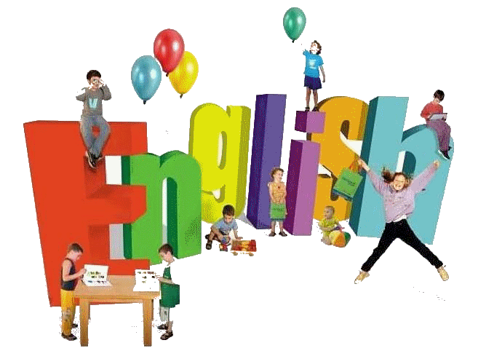

ҚОСЫМШАЛАР

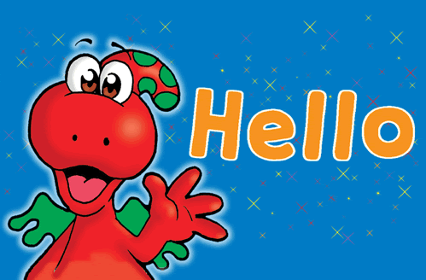
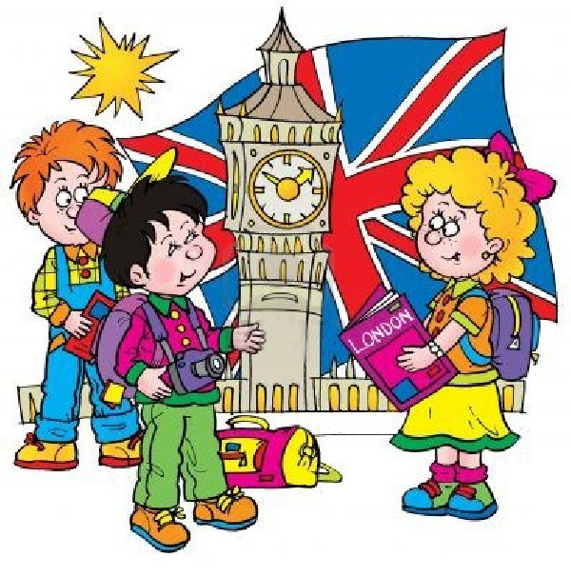

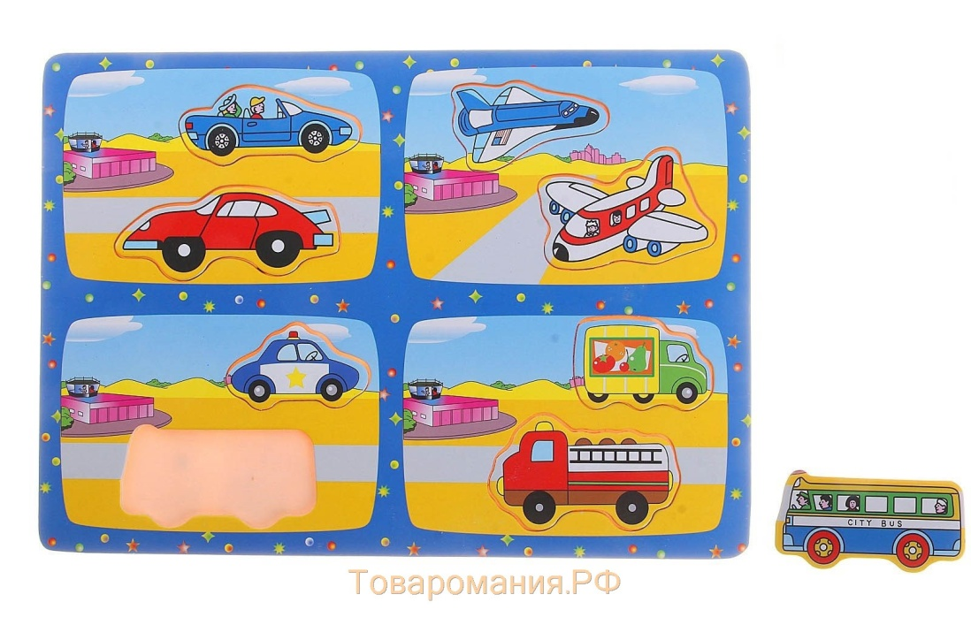

Қосымша 1

Ойындар
(Games)

A
Action Race: This is a fun game using actions. Use actions like jump, hop, clap, run etc. Have the Ss split into two teams and sit in lines with a chair by each team and one chair at the other end of the room. One S from each team stands next to their chair and T calls an action, e.g. "Jump". Ss must jump to the chair on the other side of the room and back, sitting down in their chair Ss say "I can jump". First one to do it gets their team a point. (Submitted by Gareth Thomas).
Adverb Action: T writes on the board an activity like "brush your teeth." S/He picks one student, they come to the front of the class. The T then shows the S a card with an adverb written on it, such as "slowly". The chosen student then does the activity in the way of the adverb. The other Ss have to guess the adverb. The one who guesses right gets a point and mimes the next action which the teacher writes on the board. To help them you can give them a list of options, if you think they need some help. (Submitted by Libby McArthur).
Airplane competition: First, have your Ss make some paper airplanes. Stand the Ss in a line and let them test fly their planes. For the competition, assign different classroom objects points (e.g. table 5 points, door 10 points, trash can 20 points). Ask a S a question and if s/he answers correctly then s/he can throw and try to hit one of the target objects to win points. This works well as a team game.
Apple Pass: Have all Ss sit in a circle. Use a fake apple and toss it to one S. But you must say one English word as you pass. The S then throws to another S and says a different English word. If the student you threw it to drops it, he/she is out. And the game keeps going until you have one winner. It can be played with different categories, such as Food, Animals, Etc. My students love it! (Submitted by Kim.S.).
Art Gallery: This is a great activity for reviewing vocab. Draw enough squares on the board for each S to be able to draw in. Have the Ss write their names above their squares. T calls out a word and the Ss draw it (could be simple nouns e.g. "dog, bookcase, train", verb structures e.g. "draw a man running, eating cake, sleeping") or adjectives ("draw a big elephant, an angry lion, an expensive diamond ring"). For each S give a score for his/her picture, and then move on to the next picture. The S with the highest score at the end is the winner.
Attention: Call out commands such as: Attention, salute, march in place...stop, sit down, stand up, walk in a circle, clap your hands...stop, run in place...stop, jumping jacks...stop, swim in place....stop, etc. At first students will copy you but later they should be able to do the commands without you. (Submitted by Tania Bibbo).

B
Backs to the Board Game: This one is good for higher level kids. Make two teams and stand one S from each team in front of the board, facing away from it. Write a word or draw a picture on the board (e.g. "hamburger") and the Ss have to explain that word to their team member (e.g. you can buy it in McDonalds, it's got cheese and ketchup in it). The first S out of the two standing in front of the board to guess the word wins a point for his/her team.
Badminton: Good for reviewing target vocabulary (words or communicative expressions). Set a "court" into the classroom by placing a skip-rope tied up to two chairs. Make two small teams (the other Ss can be the crowd and or challengers). Give each S a flyswatter ("Racket"). Inflate a balloon (this will be the ball). Remember: the younger the Ss, the bigger the balloon must be (slower). Decide who serves and for every winning shot the team to call out the flashcard or picture card shown by the T to get a point. Lots of fun! (NOTE: For very active Ss be careful since they might hit the others' faces when playing). (submitted by Salvador Domingo)
Banana Race: Children just love this! It is basically a QUIZ game in which you ask children questions (Target Vocabulary) like: "What's this? What fruit is red and round? How many chairs are there in the classroom?" or the T simply draws items on the board, makes animal noises so that they guess. You can work with Ss or split the class into small groups/teams if you have a large class. The T draws on the board a race track and each team or S will be a BANANA waiting at the Starting Line. They will approach the Goal line as they answer each question. Each right answer equals a step towards the Goal Line. The BANANA who arrives there first, WINS! (Submitted by Salvador Domingo).
Bang!: Materials: Small piece of paper, shoe box or coffee can. Write words on pieces of paper and fold them in half (sight words, vocab, blends etc.). Also add a few cards that say "BANG!". Ss take turns picking cards and if they read the word correctly they get to keep the word. If they draw a BANG! card they yell BANG! and then return all their cards (except the BANG! card) to the can/box. Very simple but the kids love it and there are many variations for the game! (Submitted by Heather Gilbert).
Basketball: Ss take a shot at the trash can/box/etc. First ask a question to S1. If s/he answers correctly then s/he can have a shot at the basket. If the S gets the ball in the basket then s/he wins 2 points. If the S hits the basket without going inside then s/he wins 1 point. The person who gets the most points is the winner. This can also be played in teams.
Bet you can't: This game can be played in millions and millions of different ways, and essentially it's just this: go to the toy store and buy toy money. Give each student the same amount of money at the start. Have the students bet each other that they can't do something - like this: make each S stand up and walk around. Have them say, "I bet you can't (e.g. count to 20, run around the room 5 times, sing the ABC song. etc.)". Get the Ss to bet using the toy money. You'd be surprised how much even adult students enjoy this game.
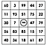Bingo: Can be played with numbers, letters, pictures or even words. The winner is the first to either get a line or full house.

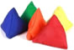Blind Toss: Have Ss sit down in a circle. Place a mat on the floor with numbers and a flashcard (target vocabulary) on each number. Taking turns, each S gets blindfolded and tosses a beanbag so as to hit a number. S/he must call out that word the same number of times as the number indicates. For example: 4-dog, then "Dog, Dog, Dog, Dog! and the S gets the equal points (4). At the end, the S with the most points wins! Good for memorizing vocabulary since they are repeating words. (Submitted by Salvador Domingo).
Blindfold Course: Make an obstacle course in your classroom (use desks, chairs, etc.), put a blindfold on a S and help guide him/her through the course by giving instructions (e.g. walk forward 2 steps, turn left, take on small step, etc.). This is a good pair game.

Blindfold Guess: Blindfold a S and give him/her an object to feel. The S must guess what the object is. This works well with plastic animals as they are a little challenging to guess (I always throw in a dinosaur to spice things up!).
Blindfold Questions: Put Ss in a circle, with one student, blindfolded standing in the middle. Turn the S around a few times. Tell the S to point at the person in front of him/her and ask a question (e.g. "How old are you?", "What's your favorite food?, etc.). After the reply the blindfolded S must guess the name of the S s/he is talking to.
Board Scramble: T puts the whole alphabet on the blackboard in a scramble of letters here and there, but low enough that the Ss can reach. Have two teams and call out a letter. The person that is able to find and circle it first wins a point for their team. To make things harder have capital and small letters. Even more challenging- have four teams all looking for the same letter. The kids just love it. You can do it with numbers and also words. (Submitted by Susie).
Buzz: A counting game. Have the Ss sit in a circle. The Ss pass the ball around while counting (1, 2, 3, etc.). When the number reaches 7 the S must say buzz. Any number with a 7 in it must be buzz (7, 17, 27, 37, etc.) and any multiple of 7 must be buzz (14, 21, 28, 35, etc.).

C
Can You Actions: Use this game for teaching "Can you...?" "Yes, I can" "No, I can't". These actions are fun: wiggle, dance, run quickly, hop, skip, do a star jump, do a handstand, touch your toes, cross your eyes, snap your fingers, whistle, sing. E.g. Ask a S "Can you cross your eyes?". If the S replies "Yes, I can" then say "Ok, go!" and the S does the action. If the S says "No, I can't" say "Too bad. Ok, can you (wiggle)?".
Category Spin: Sit Ss in a circle. Spin a bottle or an arrow - the S that the arrow points to is first. The S needs to say a word from a pre-decided category. The next S will say last word plus his own and so on until it gets to the one who fails. For example: S1:"zebra", S2: "zebra cat", S3: "zebra cat dog".
Category Tag: Choose a category (e.g. food, weather, transportation, etc.). Ss run around the room and the T chases them. When the T tags a S s/he must name a word from the category (e.g. food: cheese, fish, bread, etc.). Give a time limit to answer (e.g. 5 seconds). If the S cannot answer or says a word that has already been used s/he sits out until the next round.
Category Writing Game: Divide the classroom into two or three groups. Each group chooses their "captain". The teacher writes on the board a word like "FRUIT" or "COLORS" or "ANIMALS", etc. Each group has to tell their captain to write down as many words as they can which belong to that category. They have 1 or 2 mins. Each group takes 1 point for each word. Correct Spelling is very important in this exercise! (submitted by Eftychia Charalambous).
Charades: Have a S come to the front of the class and whisper a word or show a FC to that S. The S the acts out that word and the first S to guess can be the next player. This works very well with action verbs. Variation: divide the class up into teams - the first S to guess wins a point for his/her team.
Clothes Fun: Students form teams of 3. Each team has a bag with some clothes in it. The first team member puts on the clothes. He/She must say, "This is my shirt", "These are my trousers", "This is my hat" etc., with each item of clothing. Then when all the clothes are on, they say, " I'm dressed" and start removing the clothes, passing them to the next team member, who repeats the process. If you have some fancy high-heeled shoes and silly hats this is a really fun game! Very young beginner students will normally only say, "shirt", "hat" etc. but it's still a worthwhile game for the vocabulary. My students loved it!
Colors in the Air: This is good for very young ones. Give each S 2 pieces of different colored paper (origami paper is ideal for this). T calls a color (e.g. "Blue") and the Ss with that color hold it up. (submitted by Jo Ruoss).
Color Circles: A good activity for young kids. Get some pieces of A3 paper and draw a large circle on each one. Pin the circles on different walls in the classroom. Model the activity: Say "Blue", take a blue crayon, walk over to one circle and color a small part of the circle. Do this for each color you plan to teach. Then, say a color ("Blue") to a S and s/he should pick up the blue crayon and go over to the circle you colored in blue. Let him/her color it a little and then call him/her back. Continue with other Ss.
Color Game: This is a good one for teaching the names of colors to young children. Arrange various colors of construction paper in a circle. Play some music and have the children march around the circle. Stop the music and all the children must sit down next to a color. Pick a color and sing (to the tune of "Twinkle Twinkle Little Star"): "Who's beside the color (insert name of color)? Please stand up, if it's you." At that point, the child next to the color mentioned stands up. Continue until all of the children get a turn. (submitted by Josie Weisner).
Count-off: This game requires at least 10 kids or more. They stand in a circle or in lines. Gesture to one child and he or she says "1." Then move down the lines or around the circle counting up to 20. After 20 restart at 1. For a higher level, choose kids at random. If they're too slow or get the wrong number, they're out. Makes a great elimination game. (submitted by Michael J. Lopez).
Cross the River: Place flashcards on floor in winding manner. Each card represents a stepping stone in the river, as students must say word/phrase/question/etc in order to step on it and cross the river! (submitted by Michelle K).

D
Days of the Week March: see Months March.
Directions: Build a model of a town, including some streets. Use a radio controlled car (a toy) and give the controller to Ss. Practice directions, e.g. drive two blocks and turn right, and so on. (submitted by Francisco Amador).
Do as I say, not as I do: A 'Simon says' game with a difference. First practice Simon Says with the Ss so that they understand the game and body parts. I find it works just as well omitting the 'Simon says'. Now tell them to do as you SAY, not as you do, and repeat playing the game - only this time, when you say 'touch your knees' etc, touch your ears instead, or any other part of your body. This is a good way to see who is listening to you correctly and who is just copying your movements. Ss find this game much more fun than the original. (submitted by Lisa Coleman).
Dog & Cat Chase: Have Ss sit in a circle. T walks around the outside of the circle patting the Ss on the head saying "dog" each time. Suddenly, T says "cat" as s/he touches a S's head and then that S must chase the T around the circle. The T must try to sit in the S's spot before being tagged by the chasing S. If the T is tagged s/he must touch the heads again. If T makes it back without being touched then the chasing S walks around the circle touching heads. This can be done with any variation of words.
Draw and Roll: Split class into 2 teams. T says Draw a ______ and Ss should draw that vocabulary word. If the drawing is correct then the student rolls a dice for points. This game can be played 2 ways: The fastest person to draw the picture rolls the dice. Or the other way is to allow any student to roll the dice as long as the picture is recognizable and correct. I made my dice out of a box from the 100 Yen store. (Submitted by Tania Bibbo).
E
Exercises: This one is great for over excited Ss who need to burn off a bit of energy. It's also good for classroom commands and numbers. Stand the students in a line and call out instructions: "Jump 10 times", "Turn around 4 times" etc. Other good ones to use are: run (on the spot), hop, hands up & down, touch your (body part), stand up & sit down and star jump.
Explosion: Give the students a topic and an object to pass around. Each student has to say a word in that topic (e.g. food - apple, cake etc.) before the time runs out. If the time limit ends the student left holding the object loses. (submitted by Ben).

F
Fish: Before this game you need to have the students in pairs draw and cut out a picture of a fish for each pair. While they are doing that put 2 parallel lines of tape on the floor a few meters apart. Have Ss play in twos - each student behind a different line. T asks S1 a question. If the S answers it correctly s/he can blow once to propel the fish forward. Next, T asks S2. The S who blows the fish over the tapped line is the winner.
Fly swatter game: Divide the students into 2 teams. Give the first in each team a fly swatter. Write the same array of answers on the board for each side. Ask student A a question (a letter, blend, word, math problem, number, definition, etc.). The first one to slap the write answer on the board wins a point. They get three questions and then they pass it to the next one. When the first player gets back to the front. Change the answers and do it again! (Submitted by Tammy Edwards).
Follow the leader: Ss line up behind the T and follows him/her around the classroom. The T does an action and shouts out the word for that action. The Ss copy the action and repeat the word. Good actions include: wave hello/goodbye, it's cold/hot, stop, go, run, hop, skip, crawl, walk backwards, jump, sit down, stand up.
G
Get Dressed!: This is a game that I used with my primary school children who have just started learning English.
1. Split the class into 2 or 3 teams.
2. On the board write teams 1, 2 and 3 plus the names of the team members
3. Each team needs to designate who they are going to dress.
4. Write items of clothing (between 4 and 6 items) under each group.
5. Tell the children that the first team to dress their person is the winner. Tell them to 'get ready', count down and then empty a bin bag of clothes on the floor.
The kids loved this game. Even the 2 children who wanted to sit out and watch were screeching with laughter. To add a bit more fun, if the team has chosen to dress a boy in their group I add 'dress' or 'skirt' to their list.(Submitted by G Holwill)
Give Me Game: You can use with objects or flashcards. This works well with plastic fruit: Gather and elicit the different kinds of plastic fruit you have. Then throw all the fruit around the classroom (it's fun just to throw the whole lot in the air and watch the chaos of the Ss scrabbling to pick them up). Once the Ss have collected the fruit (they'll probably do their best to hide it in their pockets, etc.) T says "Give me an apple". The S with the apple should approach the T and hand him/her the fruit "Here you are". Avoid having the fruit thrown back to you as they can go anywhere and takes a long time to finish this game.
I spy: T says "I spy with my little eye something that begins with B". Ss try to guess the object (e.g. "book"). Colors are a good alternative for younger Ss ("... my little eye something that is red").
J
Juice: Bring a small bottle of juice (e.g. orange juice) to class. At some point during the lesson take out the bottle and have a sip. This almost certainly will cause a mini-riot of kids asking for some. Here's an ideal opportunity to teach "Can I have some juice, please?". Say this sentence to the first S and get him/her to repeat it - only give him/her some if the sentence is said correctly. Bring juice along every week, and before long your Ss will be requesting a drink in prefect English! (If you don't want your Ss to be drinking out of the same bottle as you bring along a few plastic cups).
K
Knock-Knock: This can be used at the beginning of each class. Teach the Ss to knock on the door before entering the classroom. There are 2 variations for the next step: 1. When the S knocks, T says "Who's there?". The S replies "It's (Koji)" and then the T says "Come in (Koji)". 2. When the S knocks the T must guess who it is "Is that (Koji)?". The S replies yes or no - if no, the T continues guessing. Having your Ss develop their own knocking styles makes this even more fun.
L
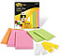Label It: This works well with newcomers of all ages who need an introduction to basic vocabulary. As long as the learners are able to identify beginning letter sounds, they should be able to do this activity. To familiarize my students with names of objects found in the classroom, I label everything with an index card that has the item's name on it. Then I have them repeat what I read as they point to the item. The next day, I remove the cards and go through them one at a time and we place them on the correct item together. The third day, I let them label whatever they can on their own. I continue this for a few days. When they are able to independently label most of the items, I surprise them by having them labeled incorrectly. Then they have to straighten out the mess. You can adapt this to any noun-based vocabulary list (e.g. types of foods, body parts, parts of a room in a house, animals, etc.) that you can post pictures of. Your website has amazing flashcards and pictures that can be printed out and used for this. (submitted by KMMP).
Last Letter, First Letter: (A popular Japanese game called Shiri Tori). Have the Ss sit in a circle with you. T starts by saying a word, then the S to the T's right must make a word that starts with the last letter of the word that the T said (e.g. bus --- steak --- key --- yellow --- etc.). Continue around the circle until someone makes a mistake.
Line True or False: Put a line of tape on the floor and designate one side "True" and the other "False". Hold up an object or flashcard and say its word. If Ss think that you have said the correct word they jump on the True side, if not they jump on the False side. Incorrect Ss sit out until the next game.
M
Machine: This is good for practicing emotions and sounds. Pick one S to start. Give that S an emotion or a feeling to act. They must do an action and make a noise. One at a time Ss can add to it and you essentially create a "machine". This is a really fun game! (Submitted by N. Budoy)
Make Words Game: Write a few random letters on the board. Have the Ss work in pairs/small groups to make up as many words from the letters as possible (e.g. letters: g, h, a, t, p, e, c. Possible words: cat, peg, tea, hat, get, etc.). The team with the most words is the winner.
Months March: For some reason my kids LOVE this game and request it every week! You'll need a fairly long classroom with space for everyone to march up and down. T stands at one end of the room against the left wall. Line the Ss up along side T and T says "Go!". As you all march together, T starts calling out the months in order ("January", " February", etc.). Ss repeat each month (T:"January" Ss:"January"). March along at a slow pace, but smartly (backs straight, arms swinging). At certain points T suddenly shouts "Stop!". Everyone must stop and be EXACTLY in line with the T. If someone is out of line order them back in line and then continue marching where you left off. Turn around each time you reach the end of the room and continue the march. Once finished start again, but this time walk briskly. You can do it the final time running! This is even more fun when there are tables, etc, in the room that the Ss need to climb over/under. After a few lessons you shouldn't have to chorus the words - just get the students to chant together as they march.
N
Name Game: Good for a first class. Sit the Ss in a circle. Point to yourself and say your name "I'm Jason". Then Ss say their names around the circle.

Name Memorizing Game: Have children sit in a circle. Start by saying "my name is.." and then answer a question about yourself. For example "My name is Jo and I like the color Purple." The next person says "This is Jo and he likes the color purple and my name is Rose and I am 8 years old." The next person says "That is Jo he likes Purple, this is Rose and she is 8 and I am Jeremy and I like the color blue." It's a chain and the kids have to repeat what the last people have said about themselves. It's really hard to be the last person in the circle! (Submitted by Danielle)
Number Codes: Cut out some squares and write numbers from 0-9 on them. Put the numbers in a box and then instruct the students to place the numbers in a line as you call them out. This also works well for phone numbers.

Number Group Game: Play some music and have your Ss walk around the classroom. Stop the music suddenly and call out a number (up to the number of Ss in your class). The Ss must quickly get together in a group of that number. Any Ss who didn't make it sit out until the next round.
O
Odd-One-Out: Write 3 or four words on the board. Ss must circle the odd-one-out (e.g. cat - horse - cake - bird).

P
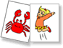Pass: Sit the Ss with you in a circle. T holds up an object or flashcard and says its name (e.g. "Pen"). T passes it on to the next S who also says its name and passes it on to the next S. Variations: change directions, speed rounds, have many objects going round at the same time.
Pictionary: Good for reviewing vocab. Pick a S and show him/her a picture or whisper a word into his/her ear. The S draws the picture on the board and the first S to guess the picture gets to draw the next picture. This can also be played in teams with a point system.
Picture Fun: Have students cut out a picture of a person in a magazine. Students should describe the person, how old they are, what their job is, what their hobbies are, etc. and then present that person to the class. This is good for practicing adjectives. (Submitted by Kelly).
Preposition Treasure Hunt: For prepositions of location and yes/no question practice. You need something sticky, like 'Blue Tak' (used for sticking posters to the wall) that you can roll into a ball and stick on anything. Model first: give the Blue Tak to a S and indicate that they should put it in a difficult-to-find place. Leave the room and give them a few moments to hide the Blue Tak (e.g. on the underside of a desk, on the wall behind a curtain, etc.). Then come back in and ask yes/no questions to locate it (Is it on the desk?, Is it near the desk? Is it in the front half of the classroom? Is it under the chair? etc.). When you finally find it have a S take the questioner's role. In a large class try having Ss play in pairs.
Puppet Conversation: Hand puppets really liven up a classroom, especially for young learners who are shy when talking to the T. You'll probably find that some Ss prefer talking to the puppet than to you! Fun puppet characters (such as Sesame Street's Cookie Monster) that talk to Ss can produce unexpected results. I always use Cookie Monster at the beginning of my young classes. Here's what I do: 1. Cookie Monster is sleeping in a bag. Each S has to shout "Wake up Cookie Monster!" into the bag. Cookie Monster only wakes up when the whole class shout together into the bag. 2. Cookie Monster says hello to each S and asks them questions (their names, how they are, how old they are, etc.). Ss reply and asks Cookie Monster the same questions. 3. Ss and Cookie Monster sing the 'Hello Song' together. 4. Cookie Monster says goodbye to each S individually and then goes back to sleep in the bag. The actual lesson can now start.
Q
Question Ball: Have the Ss sit in a circle. Throw/Roll a ball to one S and ask a question. The next step has 2 variations. Variation 1: S1 throws the ball back to the T and the T throws to another S asking a different question. Variation 2: S1 throws the ball to a different S and asks that S the same question.
Question Chain: Have the Ss sit in a circle. T asks the S next to him/her a question (e.g. "What's your name?" "Do you like chocolate cake?" etc.) and the S has to answer the question and then ask the S next to him/her the same question. Continue around the circle and then start a new question. It helps to use a ball to pass around as the questions are being asked and answered.

R
Rope Jump: you need a rope for this one! Have Ss stand behind each other in a line. Hold a rope (have a S hold the other end) at a height that the Ss should be able to jump over. On the other side of the rope spread out some objects or flashcards and a box. Call out the name of one of the objects/flashcards to the first S. S/he has to jump over the rope, pick up the correct object and put it in the box. For other rounds you can hold the rope down low, so Ss have to crawl/roll under.
Rhythmic Reading: This activity is fast-paced and lively, and improves their word recognition, speed, and confidence in reading. Choose a reading passage (one page if using a basic text, maybe one paragraph if using a more advanced one). Start a rhythm (clapping or tapping on your desk). Choose one student to start. Each student must read one sentence (or word, if you want), exactly on the beat and pronounced correctly. Immediately after the first student finishes, the next one starts with the next sentence, and so on. If someone misses a beat or stumbles over words, they lose a 'life' or they are 'out'. If you use the 'out' method, it isn't so bad, because the 'out' students help to keep the beat and follow along. In my experience, all students, whether 'out' or not, have focused intently on the reading - waiting like hawks to hear someone's mistake. Of course you can vary the tempo, making it much easier or much harder. This can also be played as a team game (which team can make it to the end of the passage, on beat, with no stumbles or mispronunciations?). Good luck! (Submitted by Melanie Mitchell).
S
Secret S: Students form 2 different groups in the class, each group prepares 3 questions to ask. Other group members try to give answers to these questions without using a word which contains the letter 'S'. The group which does not say this letter wins the game. (Submitted by Gamze Yýldýz).
Shirt Game: Divide the children into two teams and give a man's shirt to each team. Be sure each shirt has the same amount of buttons down the front. At the signal, the first person on each team puts on the shirt and buttons all of the buttons down the front. The one who is buttoned-up first gets to answer the question you ask. Of course a question equals points. If the answer is incorrect, the person from the other team gets a chance to answer.

Shopping: This can be used with a wide range of objects (plastic fruit works very well). Gather all the Ss and show them all the objects you have. Ask a S "What do you want?" (or maybe "What would you like?" to higher levels). The S should reply (e.g. "An apple, please"). T then says "Here you are" and the S finishes with "Thank you". At the end collect the objects by playing the 'Give Me' game.
Shopping Game: This is an oral communication activity appropriate for EFL learners in elementary/primary school (optimal for grades 3-6). This game is designed for practicing "shopping" dialogue and vocabulary. Materials: "produce" and play money. Object of game: To accumulate as many products as possible.
Students are divided into clerks and shoppers. Clerks set up "stands" to allow easy access for all shoppers (e.g. around the outsides of the room with their backs to the wall). Shoppers are given a set amount of money* (e.g. dollars, euros, pounds, etc.) and begin at a stand where there is an open space. Students shop, trying to accumulate as many items as possible (each item is 1 unit of currency). Periodically, the instructor will say "stop" (a bell or other device may be needed to attract attention in some cultural and classroom contexts) and call out a name of one of the products. Students with that product must then put ALL their products in a basket at the front of the room. The remaining students continue shopping. Students who had to dump their products must begin again from scratch (with fewer units of currency). The student with the most products at the end wins. Students then switch roles.
*It is recommended giving students as much money as possible since students who run out can no longer participate. Alternative play for more advanced students: Clerks set the price of items. Shoppers have the option of negotiating the price. There are two winners in this version: The shopper who accumulates the most products and the clerk who makes the most money.

Silent Ball: If the Ss are being loud and off task play this game with them. It really works and they love to play it. Have all the Ss stand up and give one student a ball (make sure it is soft). Have the students toss the ball to each other without saying a word. Any student who drops the ball or talks must sit down. (Submitted by Samantha Marchessault)

Simon Says: A good review for body parts ("Simon says touch your knees"). You could change Simon to your name to avoid confusion. When T says a sentence without the word "Simon" (e.g. "Touch your knees") then Ss shouldn't follow that instruction. If a S makes a mistake s/he has to sit out until the next round.
Slam: Sit the Ss in a circle and place some objects or flashcards in the middle of the circle. Tell Ss to put their hands on their heads. T shouts out the word of one of the objects and the Ss race to touch it. The S who touches it first get to keep the object. The S who has the most objects at the end of the game is the winner.
Smells Game: Preparation: Take eight small, empty jars; opaque jars work best (e.g., plastic vitamin containers). Put good-smelling things (e.g., shampoo, syrup) in four of the jars and bad-smelling things (e.g., vinegar, strong dried herbs) in the other four. Only a small amount is needed. Place all the jars in a big paper bag. Execution: Write "It smells good" and "It smells bad" on the board. You can also draw a happy face and a disgusted face to clarify things. Teach the phrases. Each S then comes up to teacher, one at a time. S is then blindfolded and you hold an open jar under his/her nose. S must say whether it smells good or bad. Great fun! (Submitted by Max Becker-Pos).

Snowballs: The T or the Ss draw on the board items related to the Target Lesson (fruits, animals, veggies, etc.) Make two teams. One S from each team gets a wet tissue ("Snow ball") and stands up. The rest of the class picks a card which can not be seen by the two Ss standing, who will throw their "snow ball" as they hear the other Ss call an item out (e.g.: "Apple!"). The team whose participant hits closer to the item called out, gets a point. (Submitted by Salvador)
Spelling Bee: Have all your Ss stand at the front of the class. Give S1 a word to spell. The S orally spells the word and the T writes it on the board as it is being spelt. If the spelling is wrong the S is knocked out of the game. The last S standing is the winner. This also works well as a team game.
Spin the Bottle: Sit Ss in a circle with a bottle in the middle. T Spins the bottle. When it stops spinning the S it is pointing to has to answer a question. If the answer is correct then that S can spin the bottle. This is a good class warm up activity.
Squeeze: Divide the Ss into two teams with their desks facing each other. The Ss closest to the teacher must keep their eyes open, the other Ss close their eyes. The Ss on each team must all hold hands except for the two on the ends. The two farthest away from the teacher will be reaching for a small object, like a koosh ball or bean bag. The teacher flips a coin for the Ss whose eyes are open. When it lands on heads the Ss must squeeze the hand of the next person, and then the next person and so on. When it reaches the student on the end s/he must quickly reach for the object. The team who picks up the object first wins a point. Then the line rotates, the Ss with their eyes open move to the next seat. The Ss who reached for the object come to the front. (Submitted by Lynette Jackson)
Stand Up Questions: Have the students put chairs in a circle, with one less than the number of students. The student left standing has to ask the others a question i.e. Are you wearing glasses? If the answer is yes, then the students with glasses have to stand up and quickly switch chairs, giving the one standing a chance to sit. If the answer is no, the students remain sitting. Lots of fun, and the kids seem to love it and always ask for it. Be careful that they don't get too excited and knock over any chairs. (submitted by Kirk Davies).
Stop the Bus: All Ss need pencil and paper to play this game. The T writes a letter on the board, and shouts, "Start the bus." The students then write down as many words beginning with this letter as they can think of. When one S shouts out, "Stop the bus!" everyone has to stop writing. The students all get one point for each word. The S who has the most words wins an extra 2 point. This may or may not be the one who shouted, "Stop the bus." (Submitted by Katie McArthur)
Story Pass: Put up a picture or a first sentence as a writing prompt. Divide students into small groups and have them create a story from that prompt. Each student takes a turn writing one sentence to add to the story and passes it on to the next student. Keep it going around in the group until they have finished it (it may be helpful to have a length limit or time limit so the stories don't get too out of control!). Vote on the best story, based on creativity and flow. (Submitted by Christina Deverall)

CLIL сабақтары және CLIL жұмыс парақшалары



CLIL жұмыс парақшалары
Tom’s mask

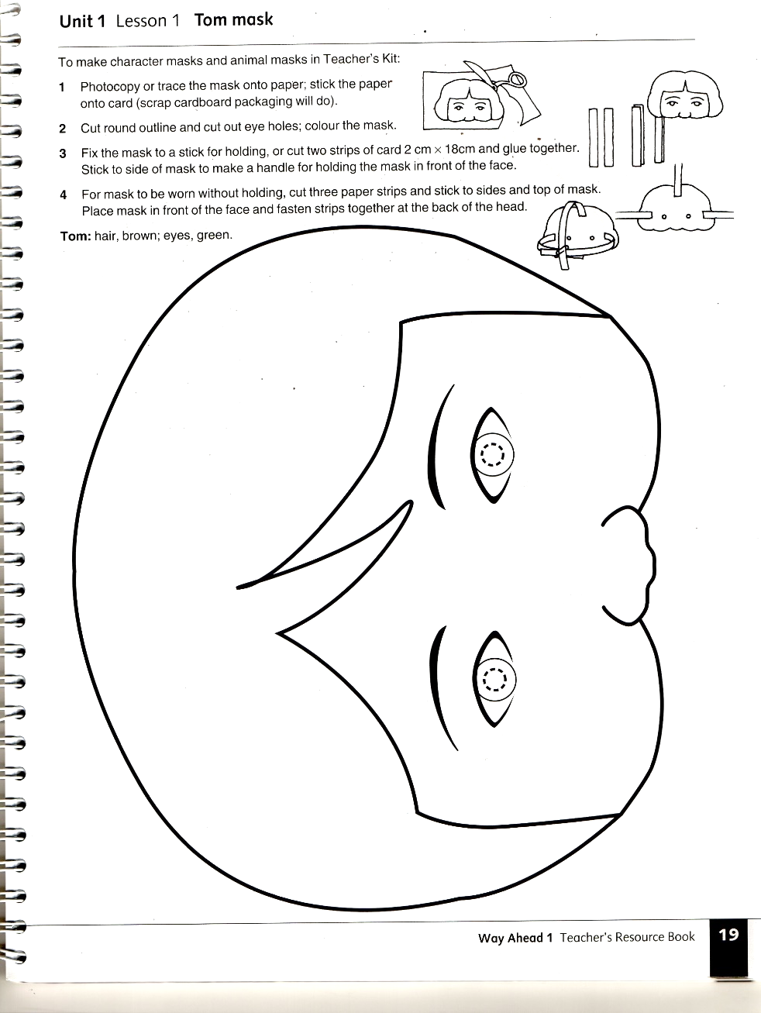

Meg’s mask

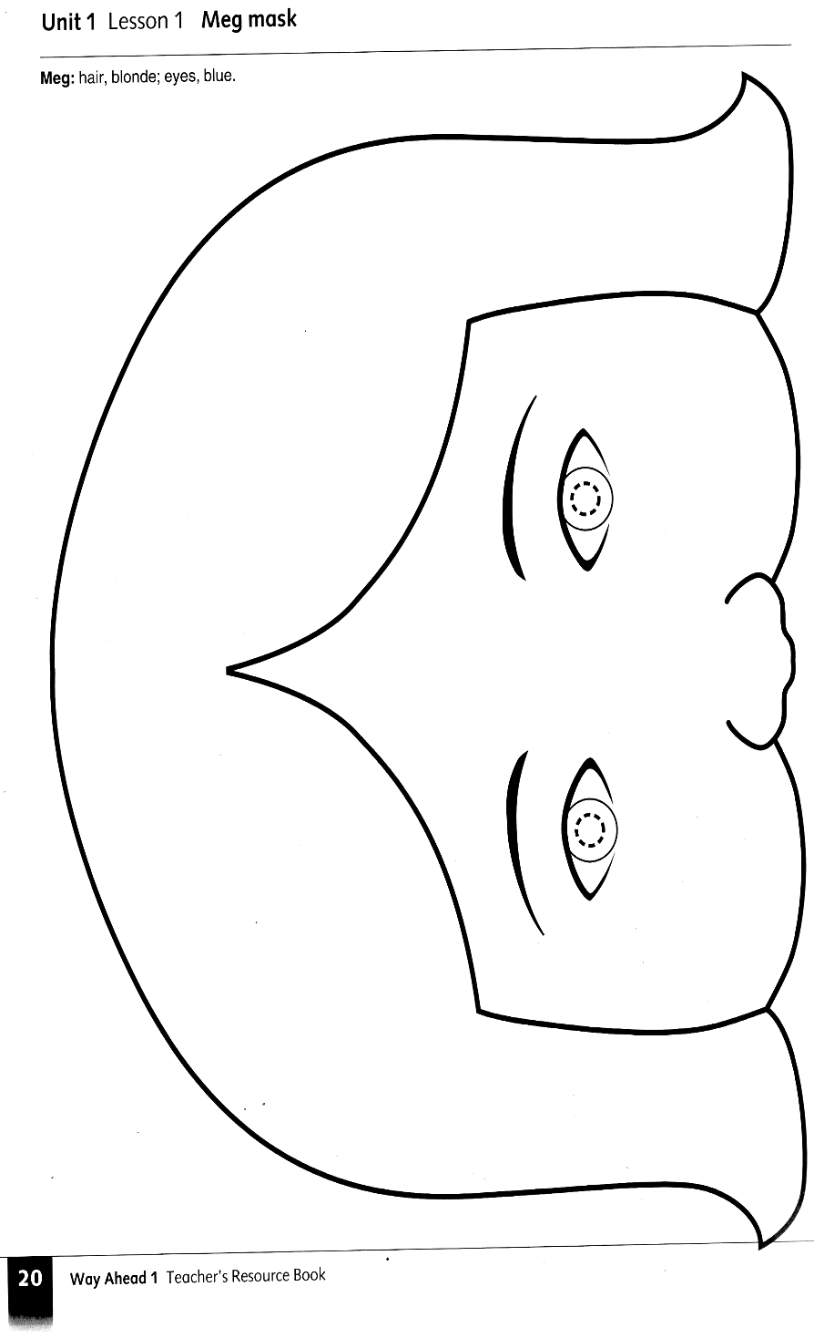

Princess puppet
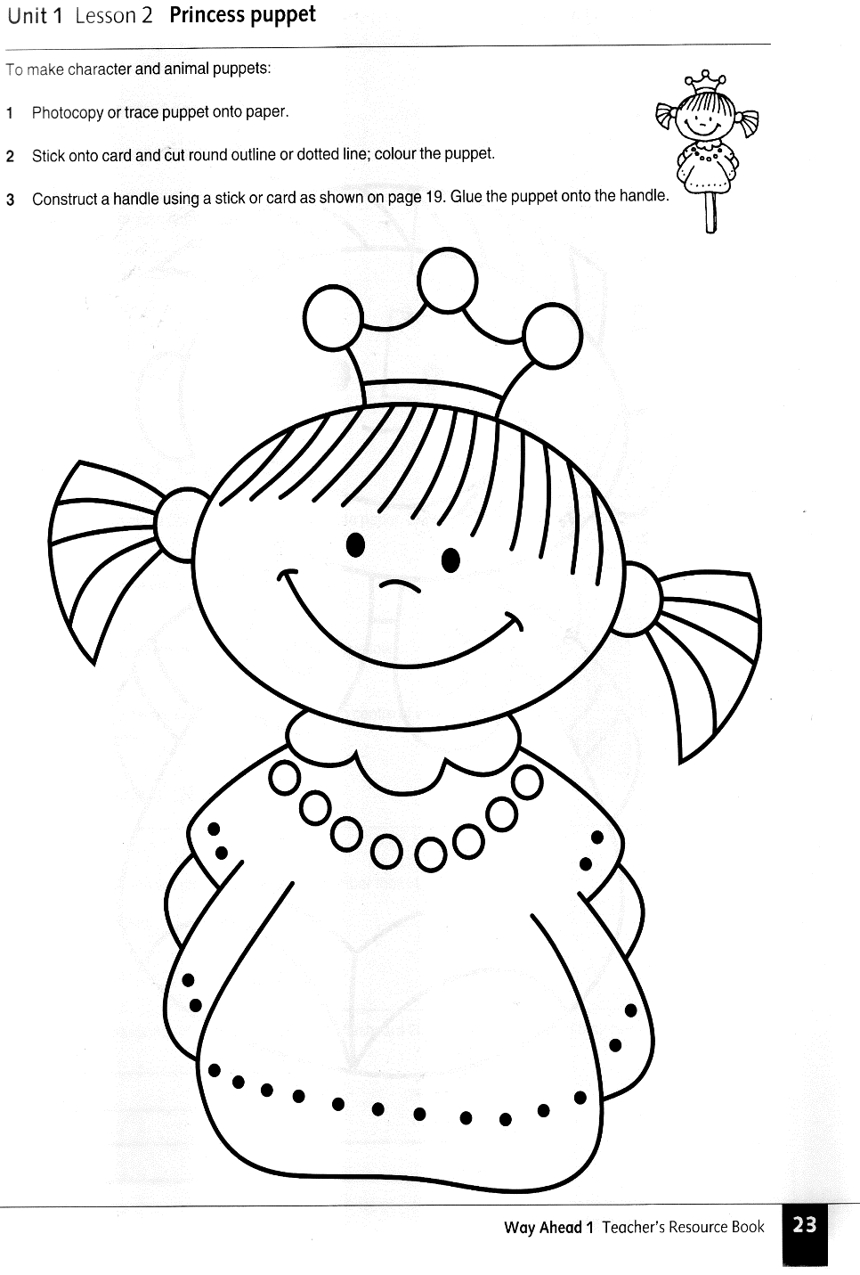

Otto puppet

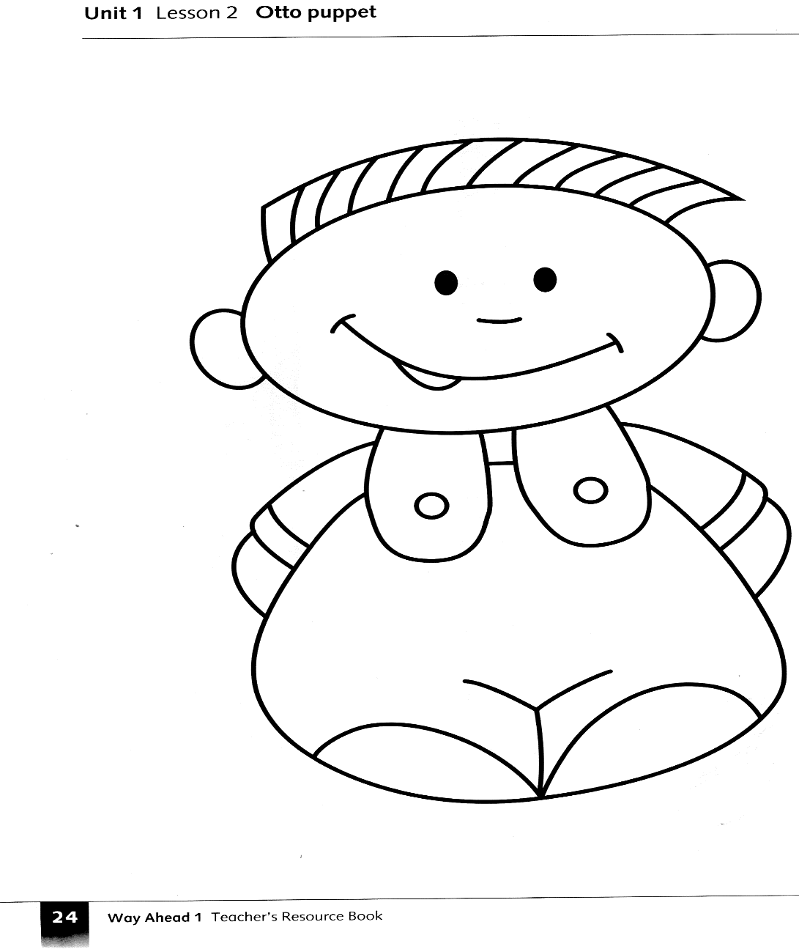

Aeroplane finger puppet
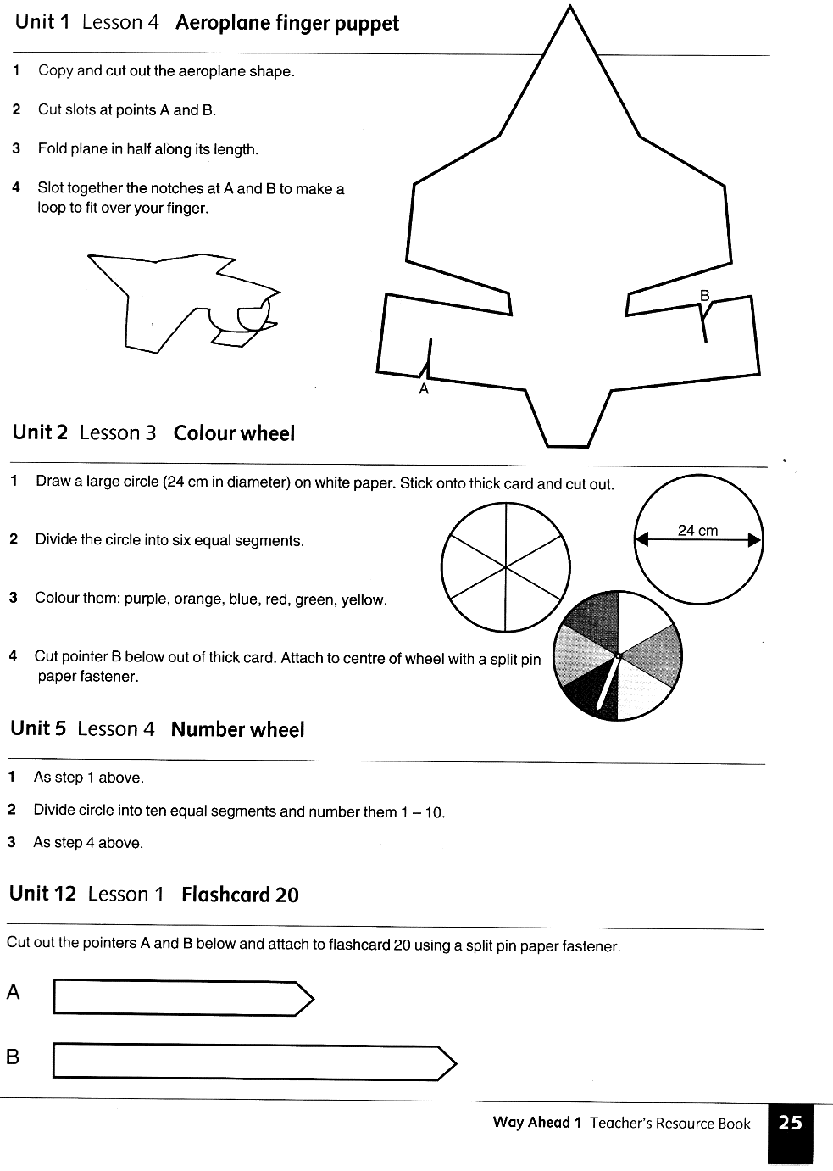

Birthday badges and frame

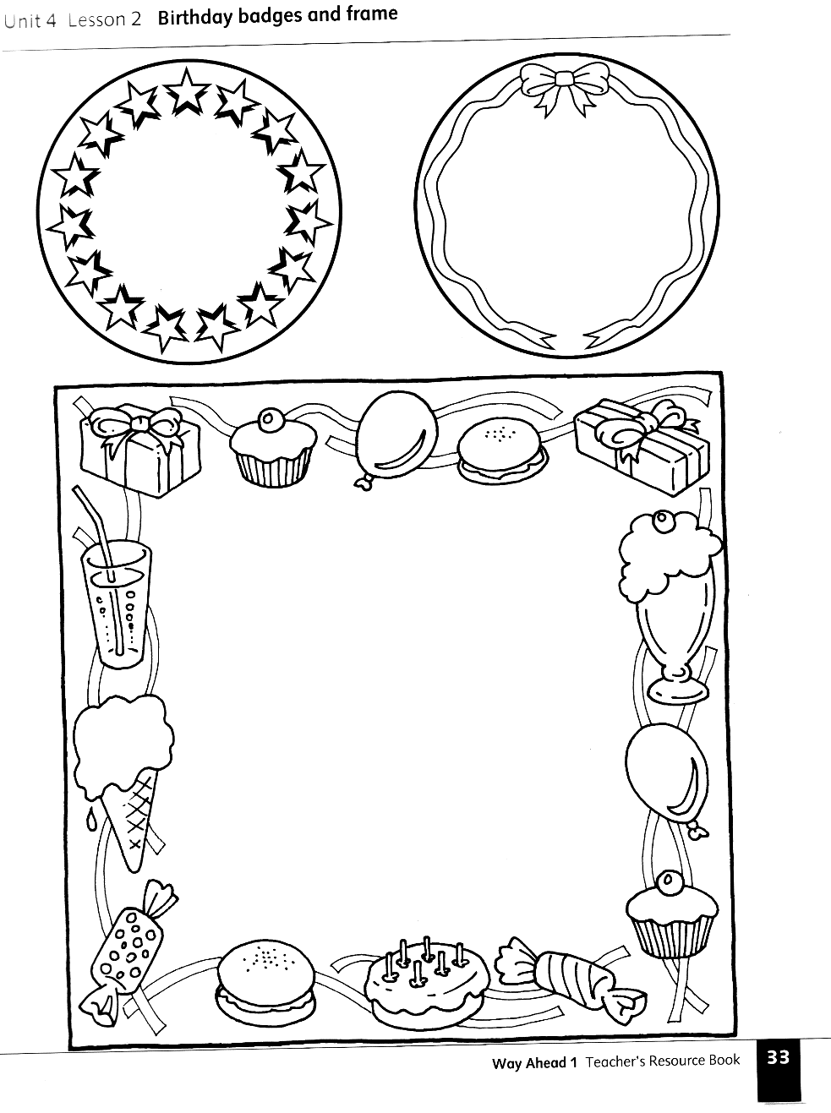

Boy doll and clothes
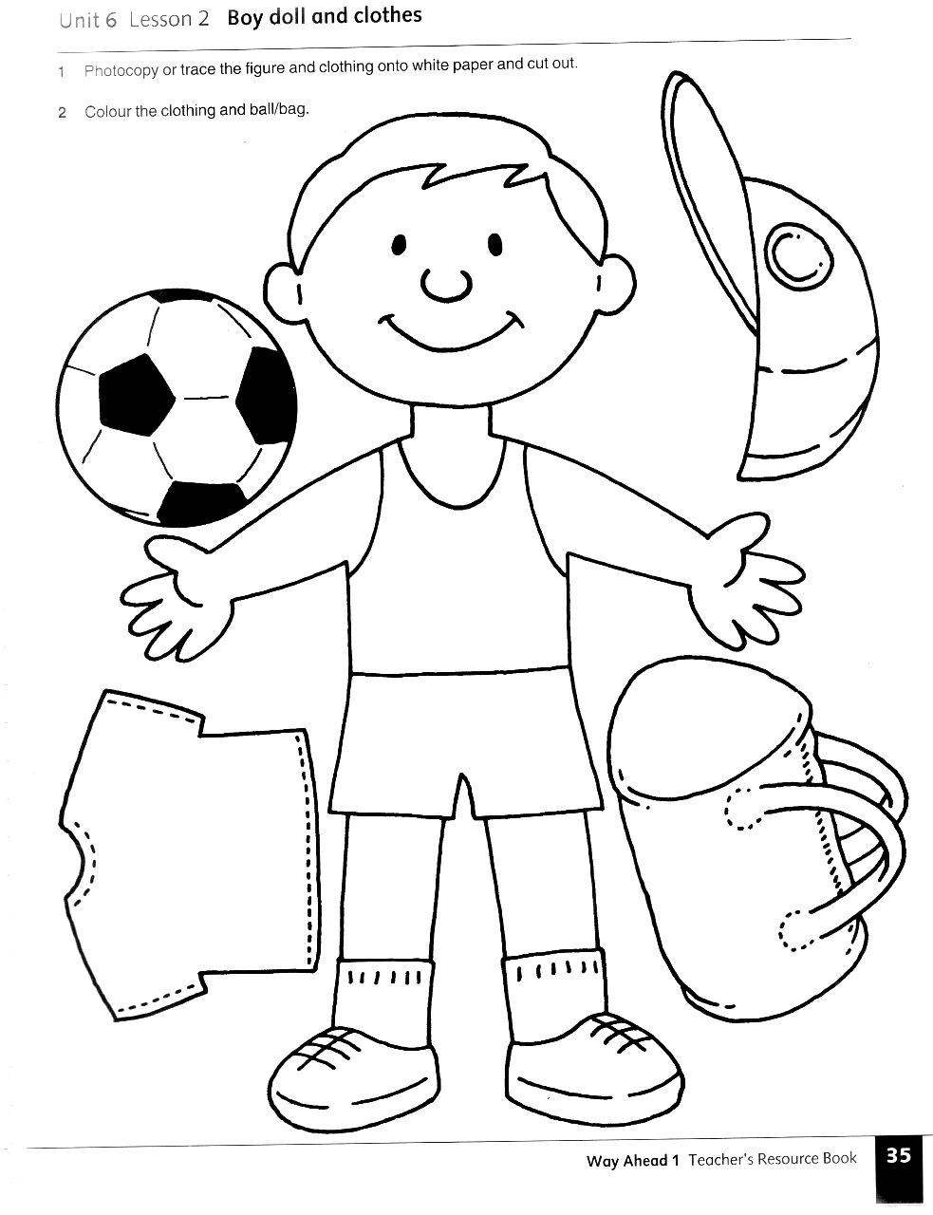

Girl doll

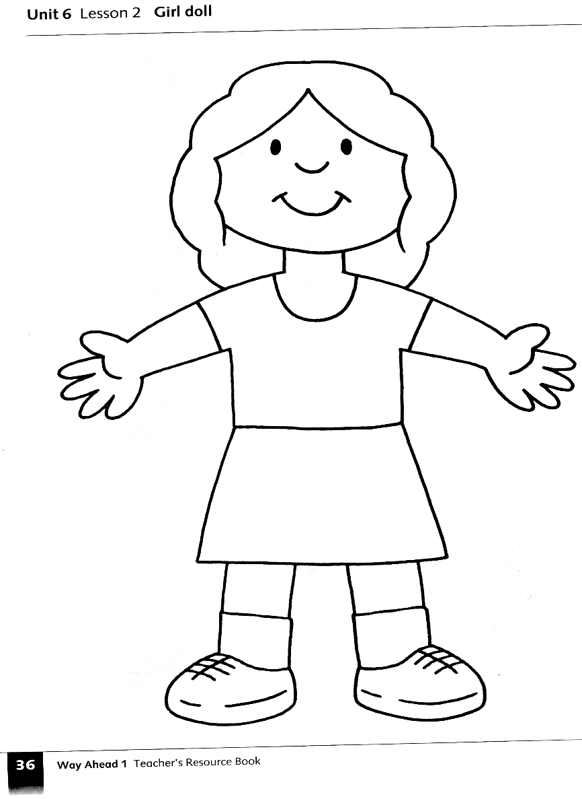

Girl doll’s clothes

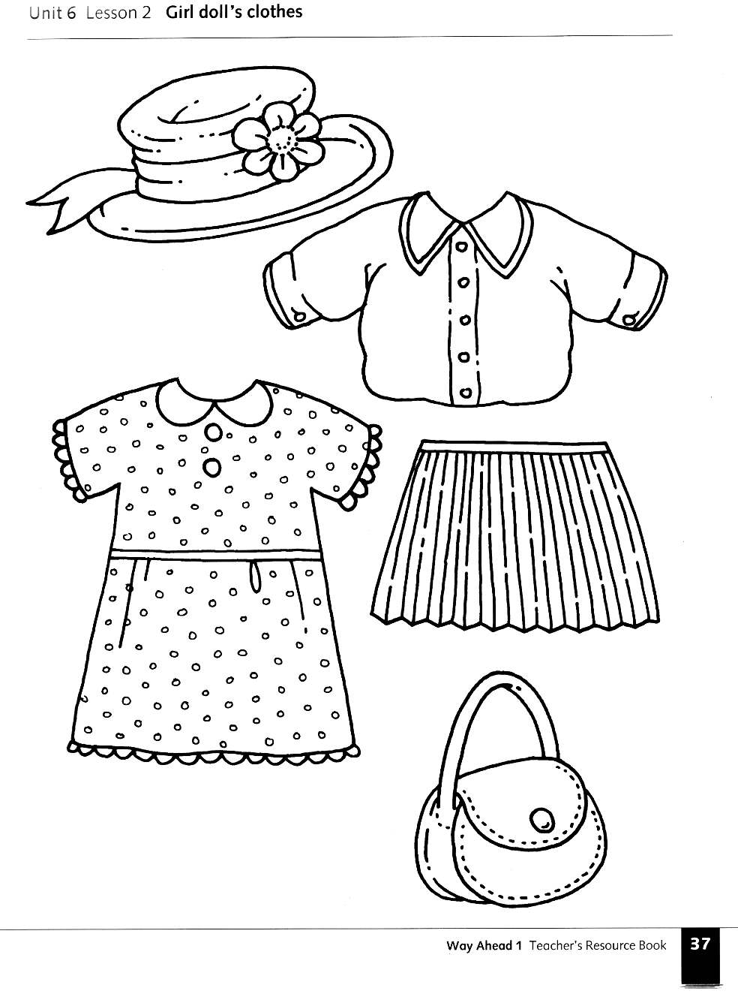

Desk. Box and object

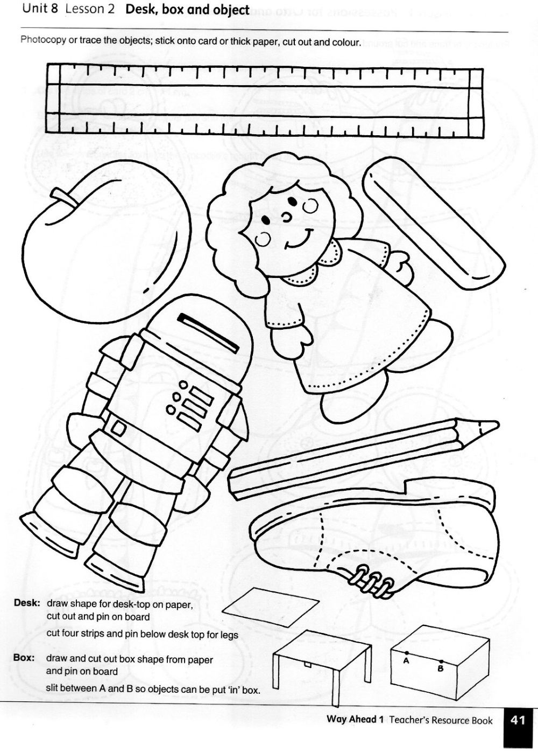

Possessions for Otto and Princess

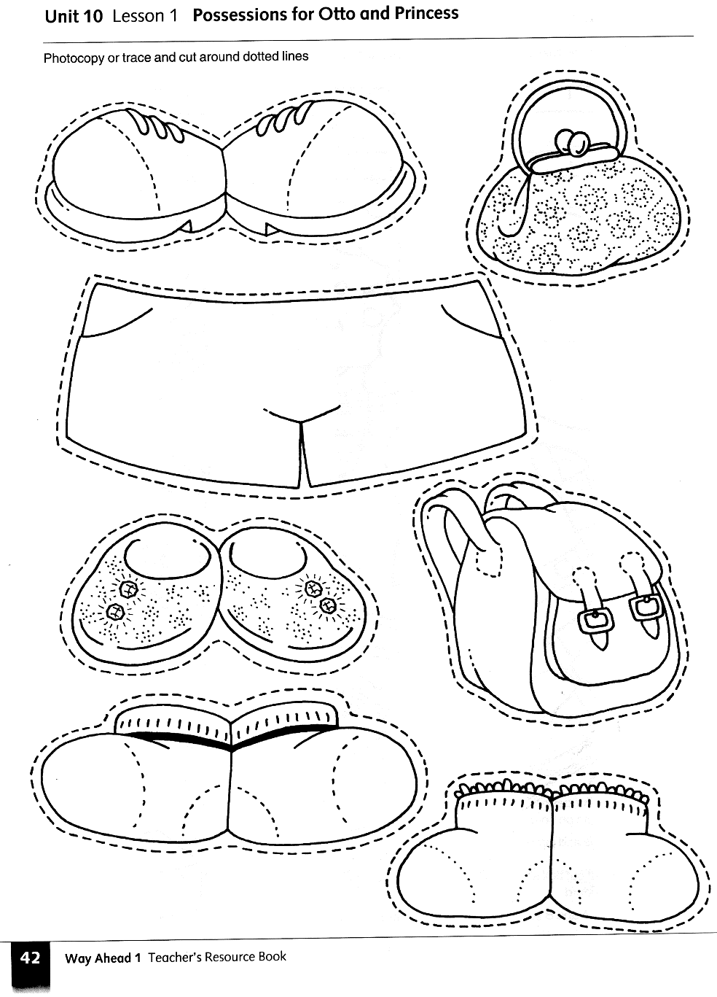

Make a Fun Tropical Feathered Friend
Materials For Each Child:
Parrot Pattern
Colourful Tissue Paper
Googly Eyes
Yarn
Markers/Crayons
Class Preparations:
Print a parrot pattern for each child. Cut a large supply of colourful tissue paper strips. Have a hole puncher and lengths of yarn ready.
Directions:
Instruct each child to cut out his parrot pattern.
Have them colour both sides of the parrot, adding an eye to the back side of the pattern.
Instruct each child to cut on the dotted lines to create wing and tail-feather openings.
Thread tissue paper strips into the opening to create wings and tail feathers.
Punch a hole near the top of the parrot and add a loop of yarn for hanging.
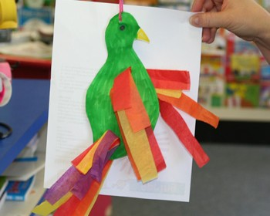

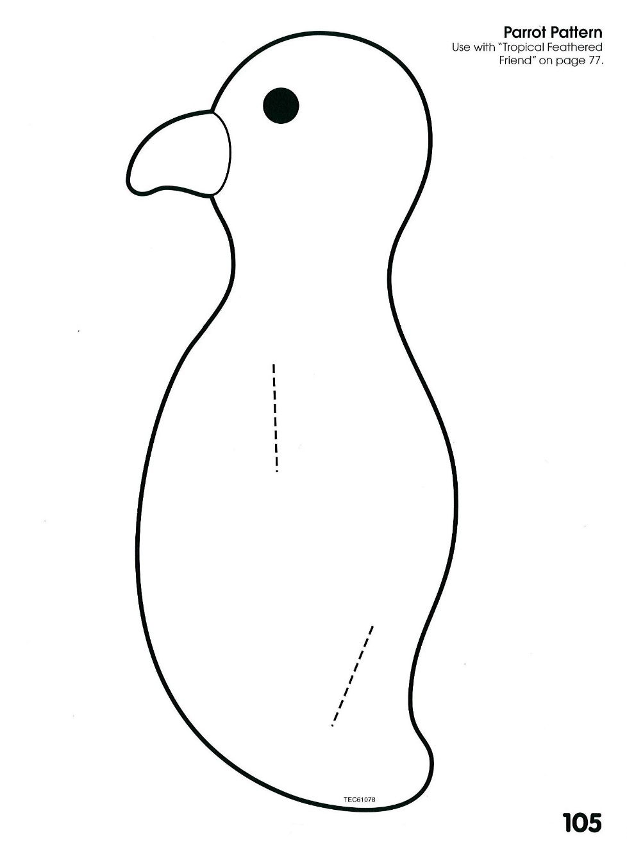

How to make paper donuts
Things you need
• colorful paper
• paper sprinkles
• glue stick
• scissors
- First of all take a sheet of brown paper and cut the circle with whole in the center
- Then take a sheet of colorful paper and cut the “frosting”
- To make sprinkles you my cut colorful sheets of paper into small pieces
- Glue the “Dough” and “Frosting”
- Decorate with sprinkles

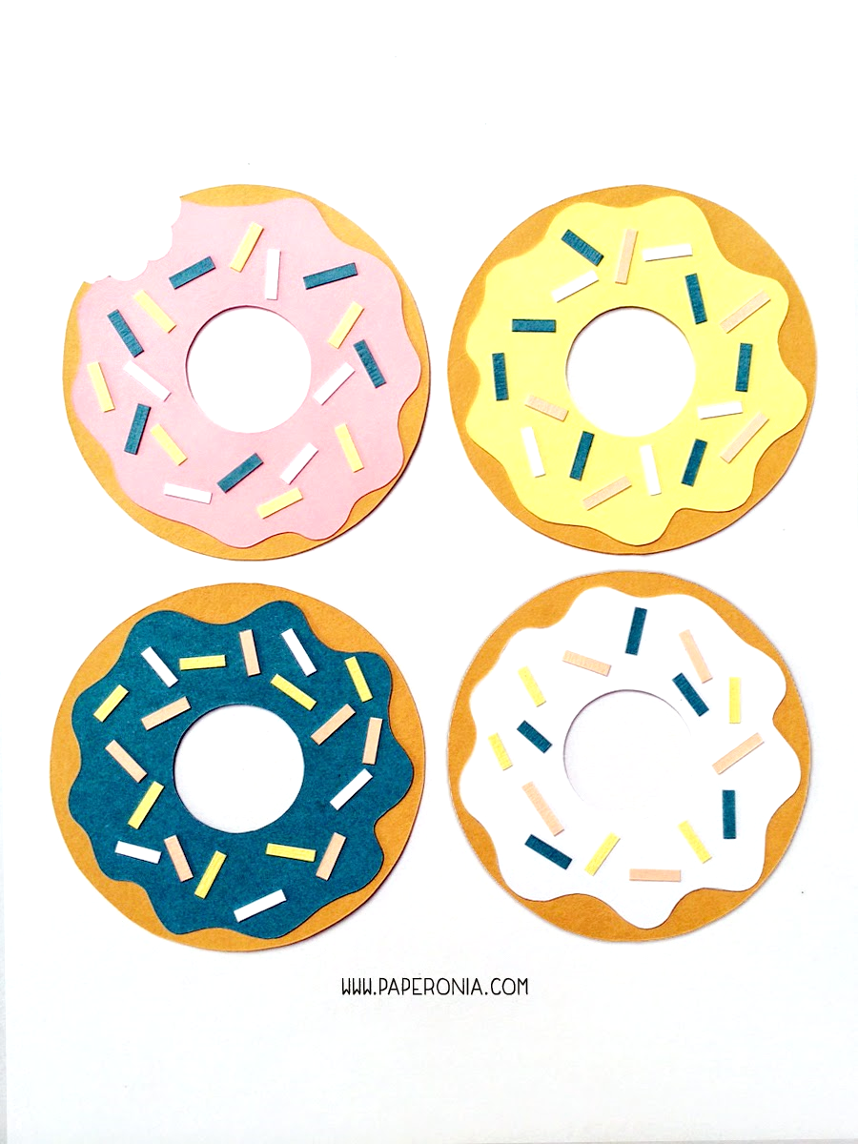
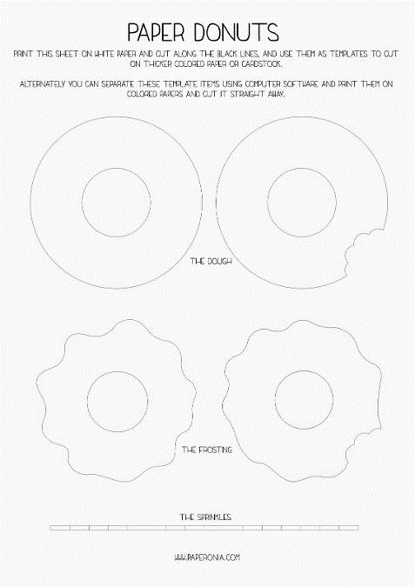

Steps
1
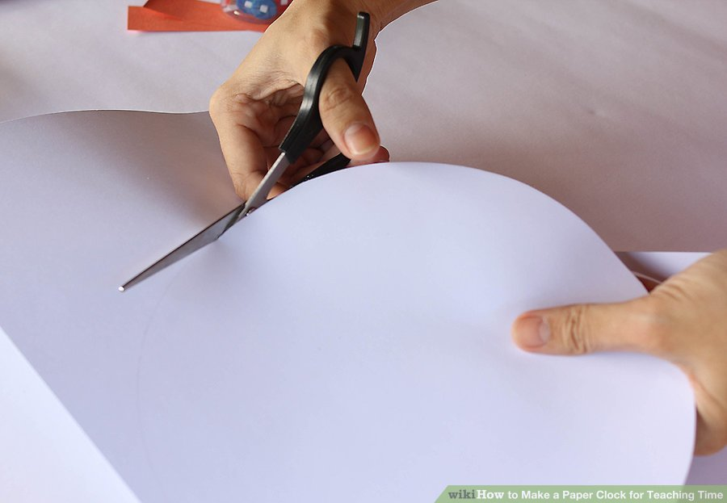
Cut out a Paper Circle for the base.
2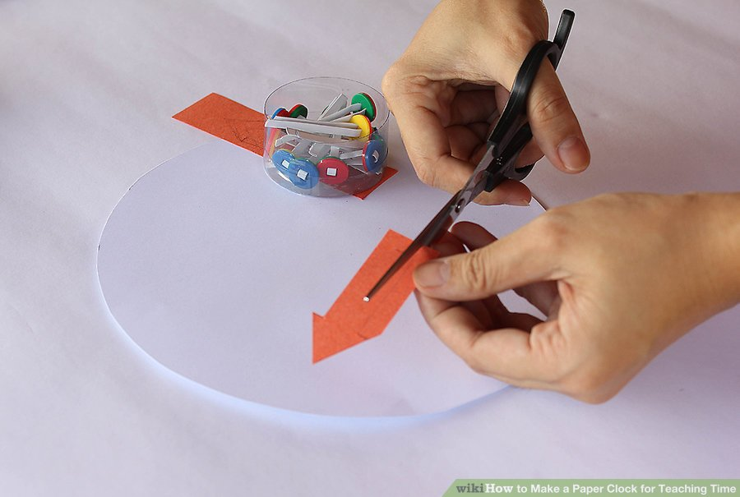
Cut out Paper Hands (arrows for the hands).

3
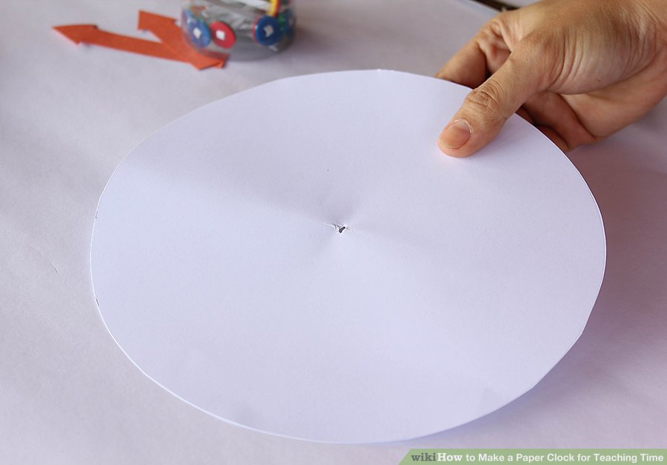
Make a hole in the middle of paper circle.

4

Attach both hands to the butterfly pin.

5
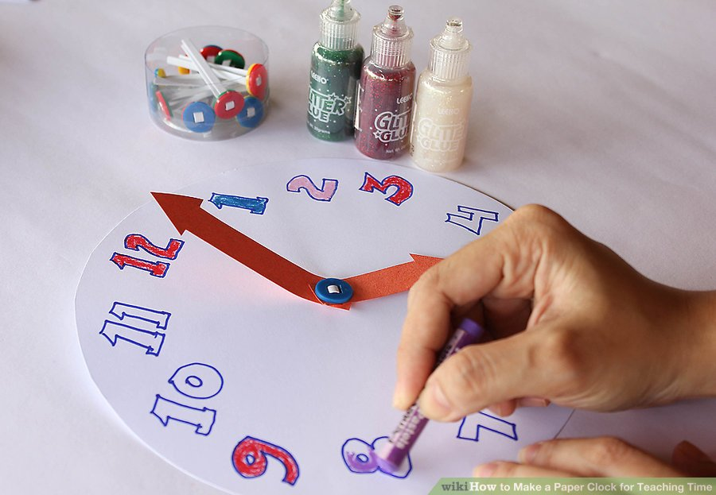
Decorate it! You don't want your audience of learners to be bored with a plain piece of paper!
6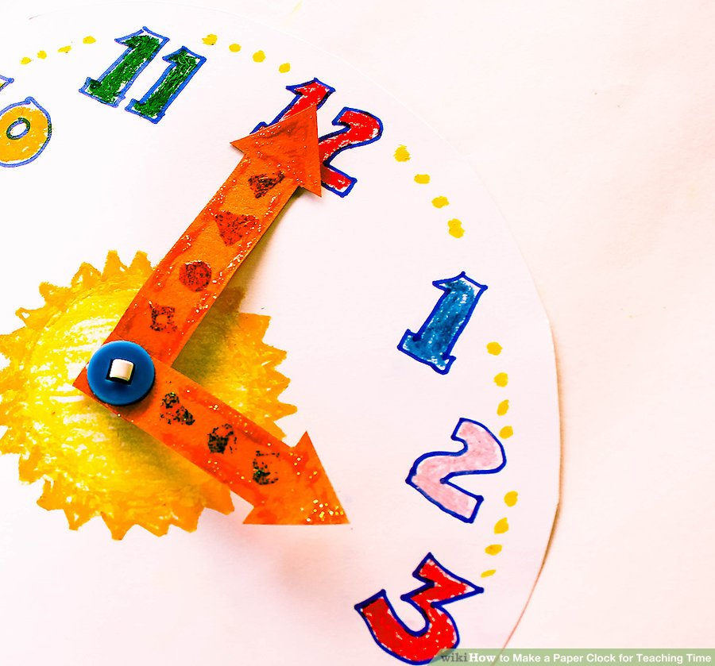
Incorporate fun games into the learning process such as who can tell the time first.


Colors
This week we talked about colors! I love this theme because there are so many great books out there that you can use.
Songs:
Color Game By: Jim Gill
Fruit Salad Salsa By: Laurie Berkner (We got in a circle and pretended the middle was the bowl and used shakers!)
My Ups and Downs By: Jim Gill

Flannel Board:
Five Little Birds
Books:
Where is the Green Sheep By: Mem Fox
I Ain’t Gonna Paint No More! By: Karen Beaumont (This one was tough because the kids didn’t get the rhyming aspect, so prob better for older kids)
Sylvie By: Jennifer Sattler
Scat the Cat (Folder Story)
Check out my Color tag on my Shelfari page for more good books that I didn’t have time to read!
Craft:
I cannot remember whose blog I got the idea for this craft from! So sorry! I will update as soon as I remember. I passed out colored strips of paper to each child and scissors. I figured I could let them cut the strips into pieces, more fun that way Then we glued them on to make a rainbow! The cotton balls add a nice cloud effect too. And I added the line on the bottom so they could write what their favorite color is. Here is the sheet I used:
Rainbow coloring sheet craft

Rainbow Craft
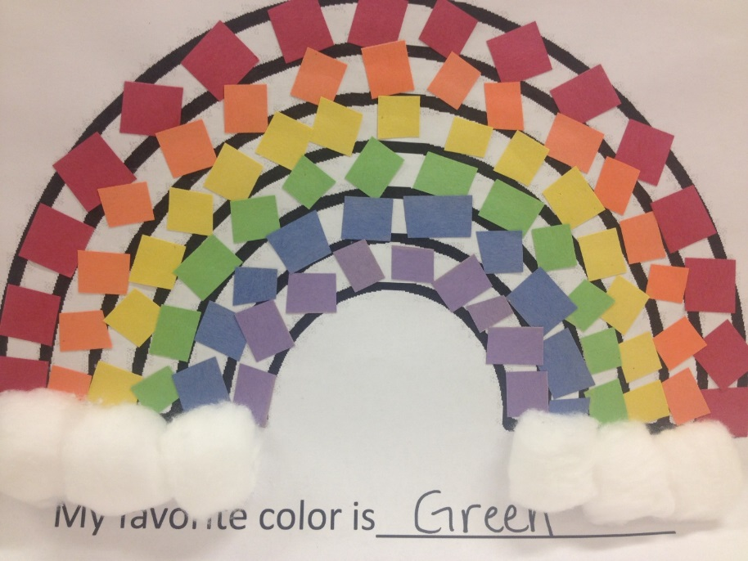

How to make cup of tea
Take a white sheet of paper and cut the cup
Then paint the cup
After that wait till paint dry
Decorate it with glitter or sprinkles
You can give it us a present for your mother
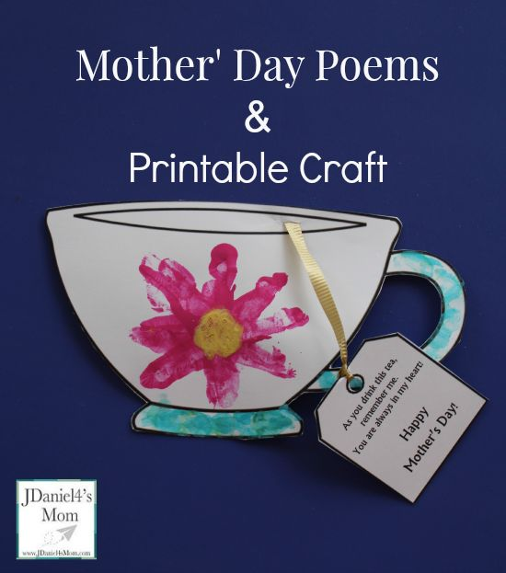
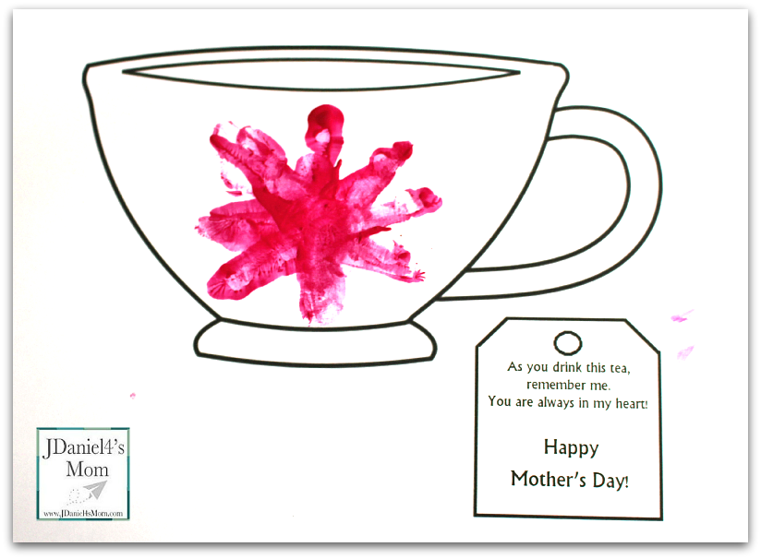
To make octopus
Who doesn't love a craft that is cute but also educational? This octopus is sure to give you that. This craft is appropriate for ages 3 and up, with younger children needing help from an adult. Have fun creating this under the sea creature and learning numbers and counting.
What you'll need:
Large piece of blue paper (or white paper painted blue)
2 different colors of construction paper for the legs and head
Green construction paper
Eyes
Glue
Marker
How to make your octopus:
Choose a color of construction paper and cut it into a half circle for the head.
Next choose a different color of paper and cut it into 8 long wavy strips for the legs.
Using your green paper cut it to look like sea weed.
Get your octopus legs and draw or attach circles or any shape you would like on each leg. One circle for one leg, 2 circles for another leg, 3 circles for the next and so on until you get to the 8th leg and draw 8 circles on the 8th leg.
Attach eyes and a smile on the octopus head along with numbers 1-8 written on the bottom.
Grab your large piece of blue paper and construct your octopus with the head on top and the sea weed on the bottom. Have your child grab a leg and count how many dots there are and decide which number it goes under. And you have yourself a fun octopus


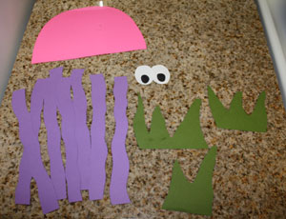
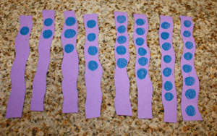

How to make a polar bear finger puppet

Supplies you will need:
- white cardstock paper
- 2 1/2-inch circle punch (optional)
- 1/2-inch circle punch
- googly eyes
- small black pom pom
- black marker
- glue stick
- scissors
Directions:
- Start by cutting out a 2 1/2-inch circle, a 4-inch circle and two polar bear ears out of your white cardstock paper.
- Punch two 1/2-inch circles out at the bottom of your larger circle. These will be the little finger holes for your puppet. Glue the 2 1/2-inch circle onto the 4-inch circle to make the polar bear head and body. Then glue the ears onto the back of the head.
- Finish your polar bear finger puppet by gluing on your googly eyes, small black pom drawing on a mouth with your black marker.
Put two of your fingers into the holes for your polar bear feet and now your cute little guy is all ready for play.
